JavaScript Tutorial

# JS Home

JavaScript is the world's most popular programming language.

JavaScript is the programming language of the Web.

JavaScript is easy to learn.

**Why Study JavaScript?**

JavaScript is one of the 3 languages all web developers must learn:

1. HTML to define the content of web pages

2. CSS to specify the layout of web pages

3. JavaScript to program the behaviour of web page

# JS Introduction

## JavaScript có thể thay đổi nội dung HTML

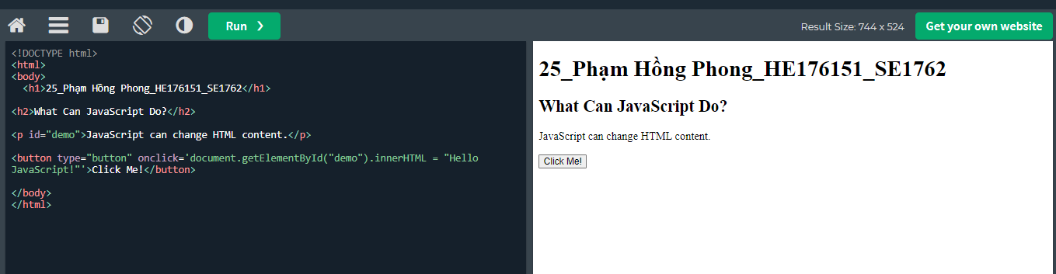

Khi click me ->’ JavaScript can change HTML content’ sẽ chuyển thành ‘Hello JavaScripts’

JavaScript accepts both double and single quotes:

## JavaScript có thể thay đổi giá trị thuộc tính HTML

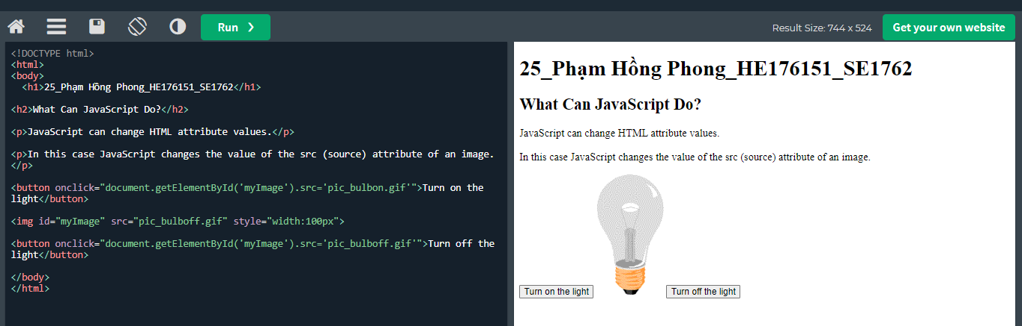

In this example JavaScript changes the value of the src (source) attribute of an <img> tag:

## JavaScript có thể thay đổi kiểu HTML (CSS)

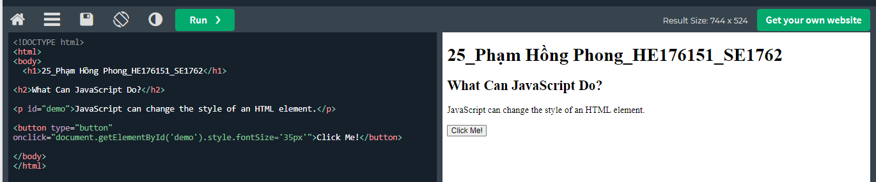

After click me

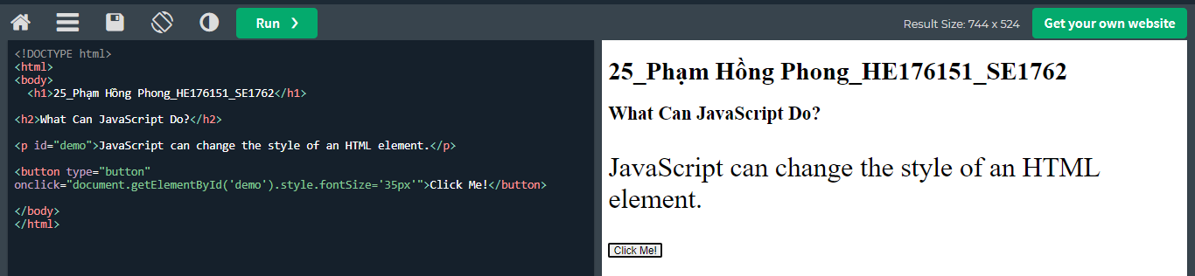

## JavaScript Can Show HTML Elements

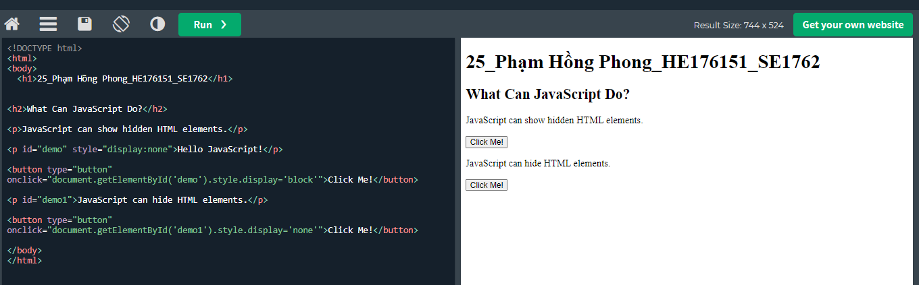

# JS Where To

## The <script> Tag

In HTML, JavaScript code is inserted between <script> and </script> tags.

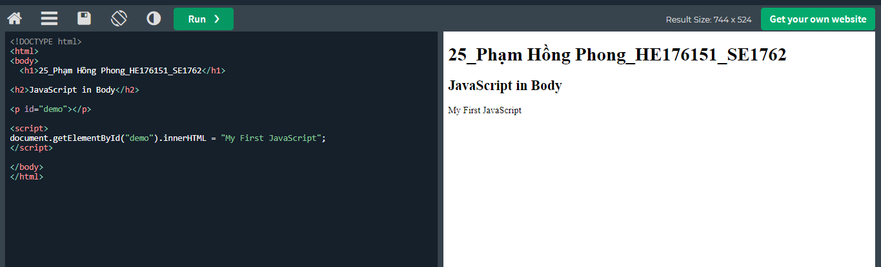

Old JavaScript examples may use a type attribute: <script type="text/javascript">.

The type attribute is not required. JavaScript is the default scripting language in HTML.

## JavaScript Functions and Events

Hàm JavaScript là một khối mã JavaScript, có thể được thực thi khi được "gọi".

Ví dụ: một hàm có thể được gọi khi một sự kiện xảy ra, như khi người dùng nhấp vào nút.

## JavaScript in <head> or <body>

You can place any number of scripts in an HTML document.

Scripts can be placed in the <body>, or in the <head> section of an HTML page, or in both.

## JavaScript in <head>

In this example, a JavaScript function is placed in the <head> section of an HTML page.

The function is invoked (called) when a button is clicked:

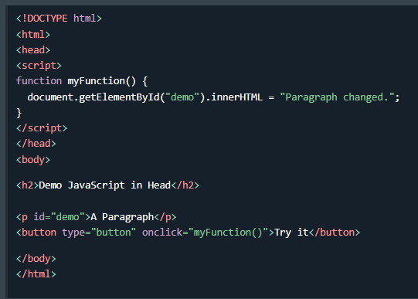

## JavaScript in <body>

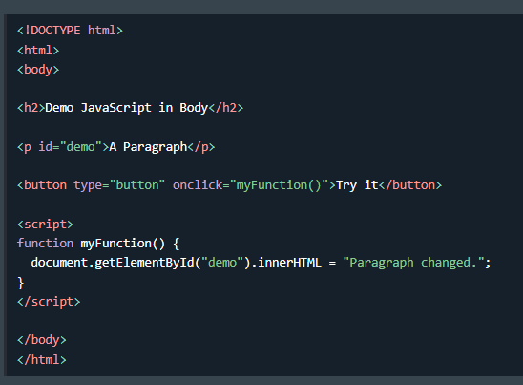

Placing scripts at the bottom of the <body> element improves the display speed, because script interpretation slows down the display.

## External Javascript

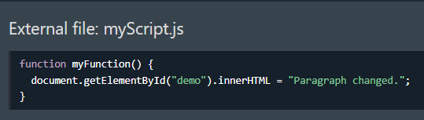

External scripts are practical when the same code is used in many different web pages.

JavaScript files have the file extension .js.

To use an external script, put the name of the script file in the src (source) attribute of a <script> tag:

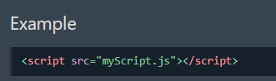

You can place an external script reference in <head> or <body> as you like.

The script will behave as if it was located exactly where the <script> tag is located.

External scripts cannot contain <script> tags.

External JavaScript Advantages

Placing scripts in external files has some advantages:

* It separates HTML and code
* It makes HTML and JavaScript easier to read and maintain
* Cached JavaScript files can speed up page loads

An external script can be referenced in 3 different ways:

* With a full URL (a full web address)
* With a file path (like /js/)
* Without any path

# JS Output

## JavaScript Display Possibilities

JavaScript can "display" data in different ways:

* Writing into an HTML element, using innerHTML.
* Writing into the HTML output using document.write().
* Writing into an alert box, using window.alert().
* Writing into the browser console, using console.log().

## Using innerHTML

To access an HTML element, JavaScript can use the document.getElementById(id) method.

The id attribute defines the HTML element. The innerHTML property defines the HTML content:

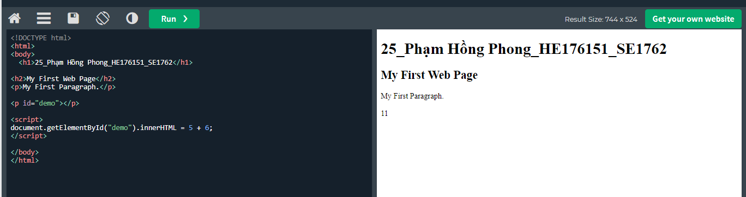

Changing the innerHTML property of an HTML element is a common way to display data in HTML

## Using document. write()

For testing purposes, it is convenient to use document.write()

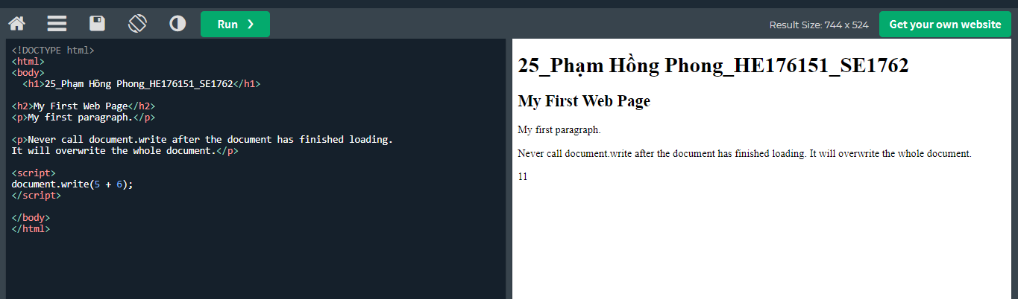

Using document.write() after an HTML document is loaded, will delete all existing HTML:

## Using window.write()

The document.write() method should only be used for testing.

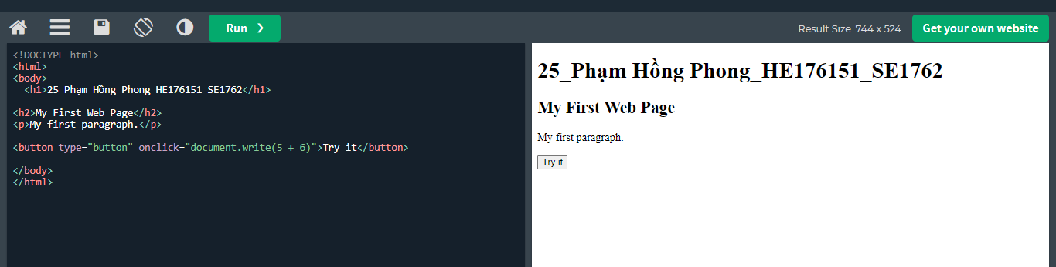

After click ‘Try it’

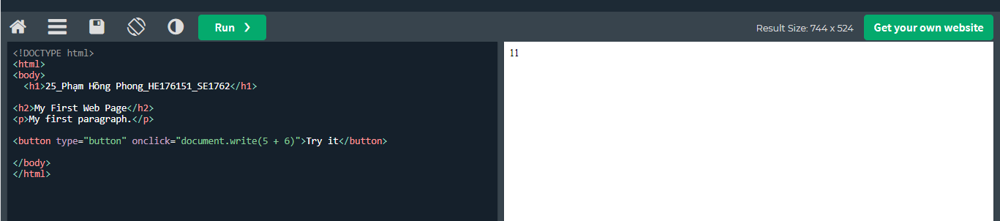

## Using window.alert()

You can skip the window keyword.

In JavaScript, the window object is the global scope object.

This means that variables, properties, and methods by default belong to the window object. This also means that specifying the window keyword is optional:

## 

## Using console.log()

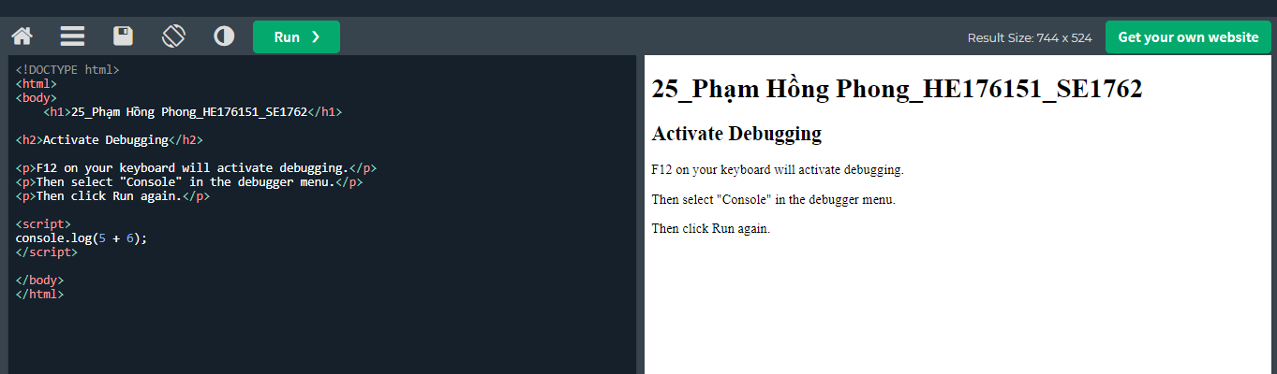

## JavaScript Print

JavaScript does not have any print object or print methods.

You cannot access output devices from JavaScript.

The only exception is that you can call the window.print() method in the browser to print the content of the current window.

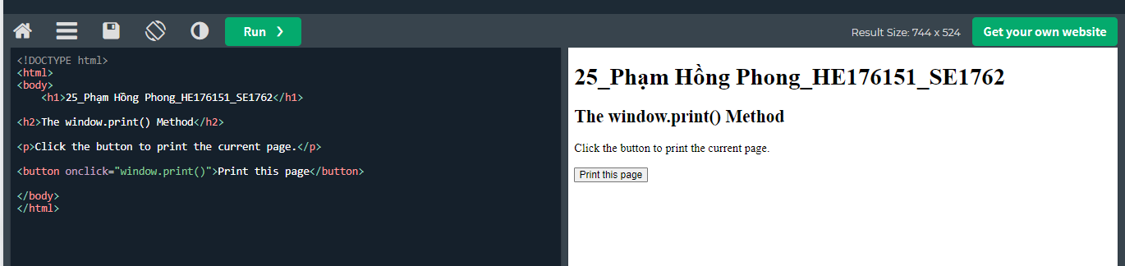

After onclick

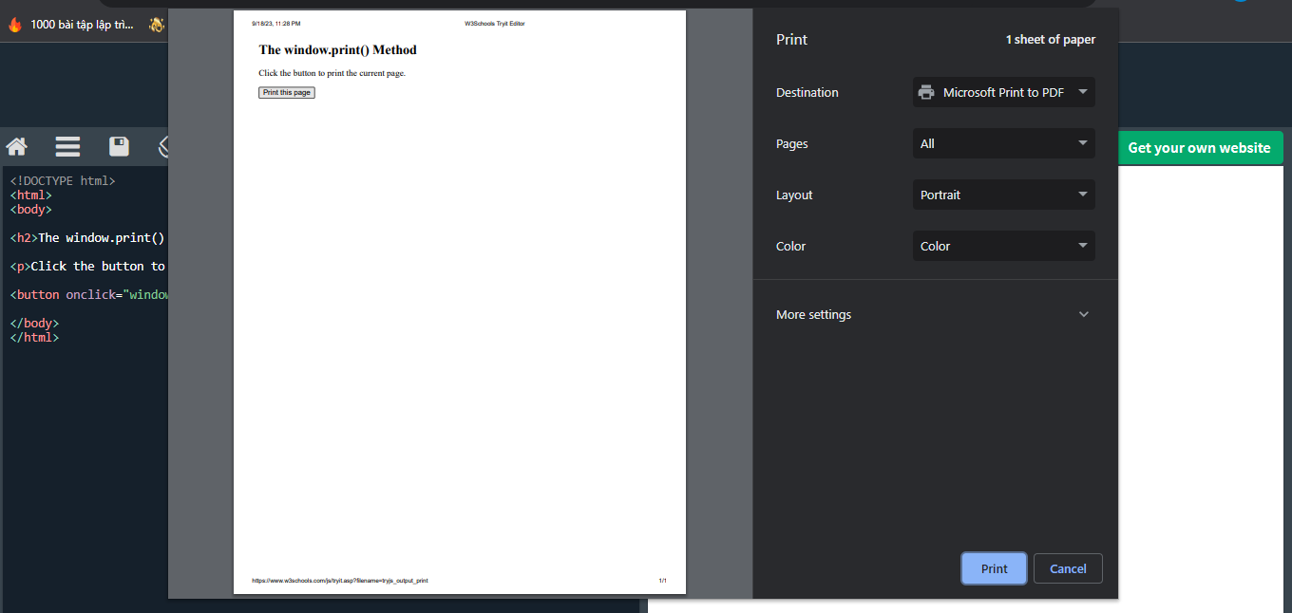

# JS Statements

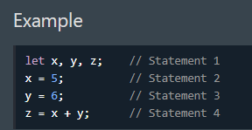

## JavaScript Programs

A computer program is a list of "instructions" to be "executed" by a computer.

In a programming language, these programming instructions are called statements.

A JavaScript program is a list of programming statements.

In HTML, JavaScript programs are executed by the web browser.

## JavaScript Statements

JavaScript statements are composed of:

Values, Operators, Expressions, Keywords, and Comments.

This statement tells the browser to write "Hello Dolly." inside an HTML element with id="demo":

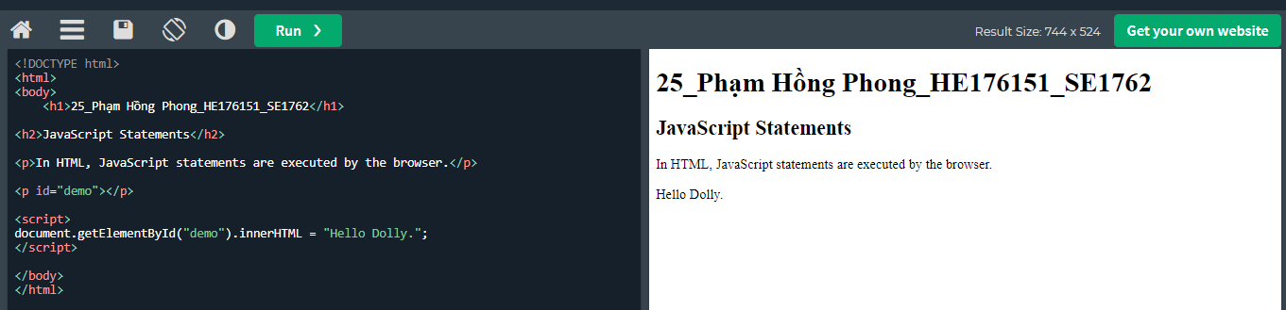

Most JavaScript programs contain many JavaScript statements.

The statements are executed, one by one, in the same order as they are written.

JavaScript programs (and JavaScript statements) are often called JavaScript code.

## Semicolon;

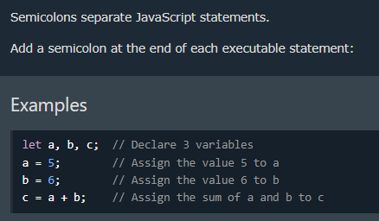

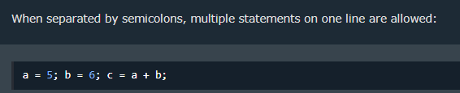

On the web, you might see examples without semicolons.

Ending statements with semicolons is not required, but highly recommended.

**Recommend using semiclons**

## JavaScript White Space

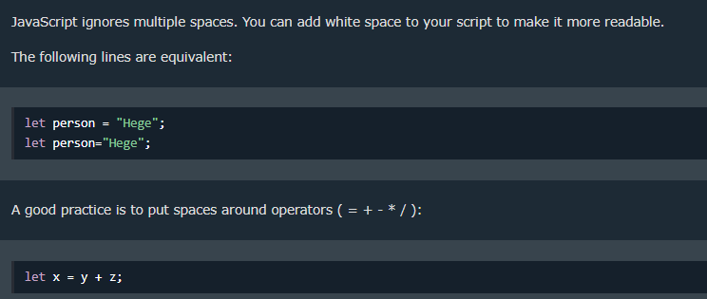

## JavaScript Line Length and Line Breaks

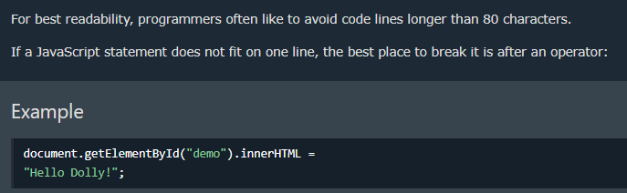

## JavaScript Code Blocks

JavaScript statements can be grouped together in code blocks, inside curly brackets {...}.

The purpose of code blocks is to define statements to be executed together.

One place you will find statements grouped together in blocks, is in JavaScript functions:

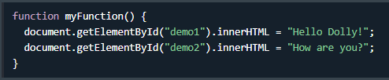

## Keywords

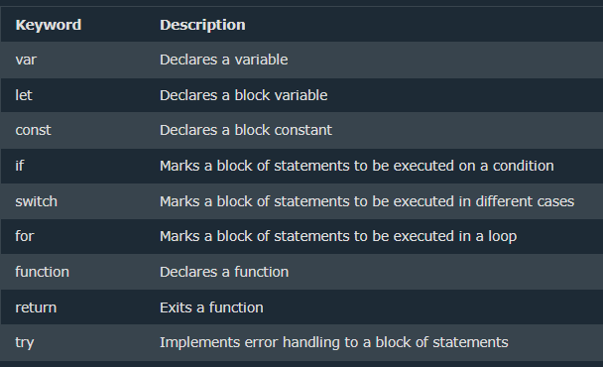

JavaScript keywords are reserved words. Reserved words cannot be used as names for variables.

# JS Syntax

JavaScript syntax is the set of rules, how JavaScript programs are constructed:

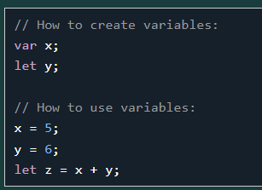

## JavaScript Values

The JavaScript syntax defines two types of values:

* Fixed values
* Variable values

Fixed values are called Literals.

Variable values are called Variables.

## JS Literals

The two most important syntax rules for fixed values are:

1.Numbers are written with or without decimals:

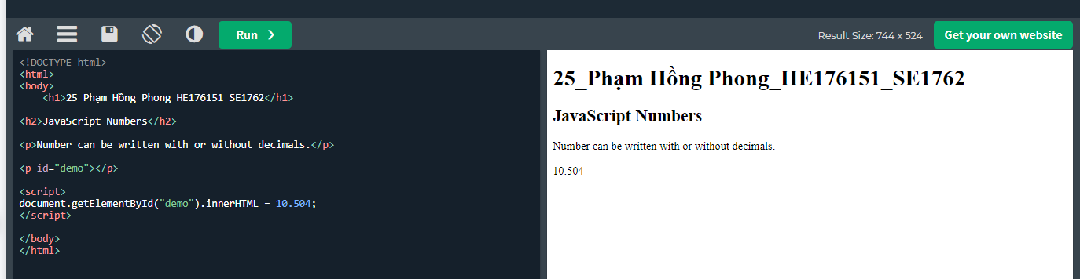

2. Strings are text, written within double or single quotes:

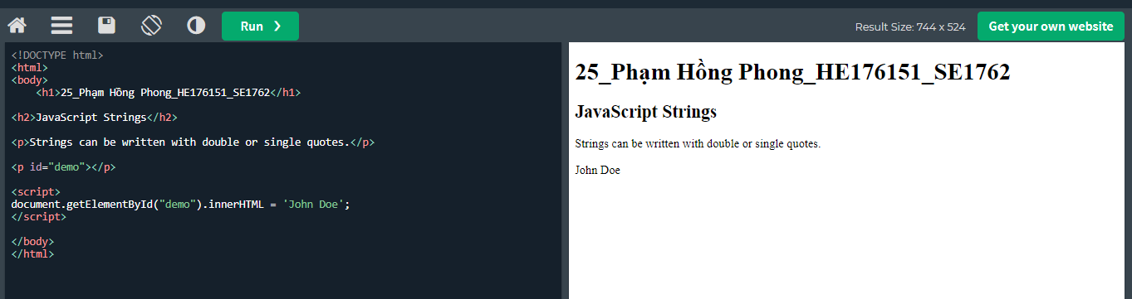

## JS Variables

In a programming language, variables are used to store data values.

JavaScript uses the keywords var, let and const to declare variables.

An equal sign is used to assign values to variables.

In this example, x is defined as a variable. Then, x is assigned (given) the value 6:

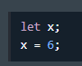

## JS Operators

JavaScript uses arithmetic operators ( + - * / ) to compute values:

JavaScript uses an assignment operator ( = ) to assign values to variables:

## JS keywords

JavaScript keywords are used to identify actions to be performed.

* The let keyword tells the browser to create variables:
* The var keyword also tells the browser to create variables:

In these examples, using var or let will produce the same result.

## JS Comments

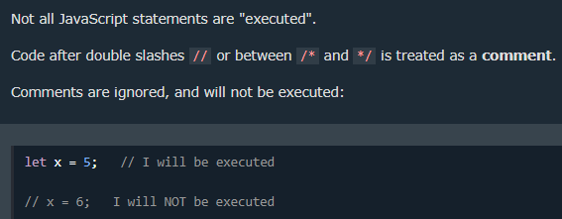

## JavaScript Identifiers / Names

Identifiers are JavaScript names.

Identifiers are used to name variables and keywords, and functions.

The rules for legal names are the same in most programming languages.

A JavaScript name must begin with:

* A letter (A-Z or a-z)
* A dollar sign ($)
* Or an underscore (_)

Subsequent characters may be letters, digits, underscores, or dollar signs.

Numbers are not allowed as the first character in names.

This way JavaScript can easily distinguish identifiers from numbers.

## JS is Case Sensitive

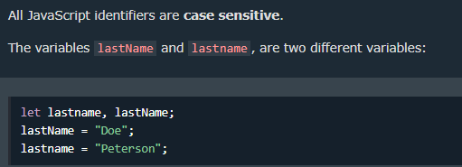

JavaScript does not interpret LET or Let as the keyword let.

## JavaScript and Camel Case

Historically, programmers have used different ways of joining multiple words into one variable name:

Hyphens:first-name, last-name, master-card, inter-city.

Hyphens are not allowed in JavaScript. They are reserved for subtractions.

Underscore:first_name, last_name, master_card, inter_city.

Upper Camel Case (Pascal Case):FirstName, LastName, MasterCard, InterCity.

Lower Camel Case:

JavaScript programmers tend to use camel case that starts with a lowercase letter:

firstName, lastName, masterCard, interCity.

## JavaScript Character Set

JavaScript uses the Unicode character set.

Unicode covers (almost) all the characters, punctuations, and symbols in the world.

# JS Comments

## Single line: // in front of a code line

## Multi-line Comments:

Multi-line comments start with /* and end with */.

Any text between /* and */ will be ignored by JavaScript.

# JS Variables

## Variables are Containers for Storing Data

JavaScript Variables can be declared in 4 ways:

* Automatically
* Using var
* Using let
* Using const

Note: It is considered good programming practice to always declare variables before use.

The var keyword was used in all JavaScript code from 1995 to 2015.

The let and const keywords were added to JavaScript in 2015.

The var keyword should only be used in code written for older browsers.

## When to Use var, let, or const?

1. Always declare variables

2. Always use const if the value should not be changed

3. Always use const if the type should not be changed (Arrays and Objects)

4. Only use let if you can't use const

5. Only use var if you MUST support old browsers.

## JavaScript Identifiers

All JavaScript variables must be identified with unique names.

These unique names are called identifiers.

Identifiers can be short names (like x and y) or more descriptive names (age, sum, totalVolume).

The general rules for constructing names for variables (unique identifiers) are:

* Names can contain letters, digits, underscores, and dollar signs.
* Names must begin with a letter.
* Names can also begin with $ and _ (but we will not use it in this tutorial).
* Names are case sensitive (y and Y are different variables).
* Reserved words (like JavaScript keywords) cannot be used as names.

JavaScript identifiers are case-sensitive.

The "equal to" operator is written like == in JavaScript.

## Declaring

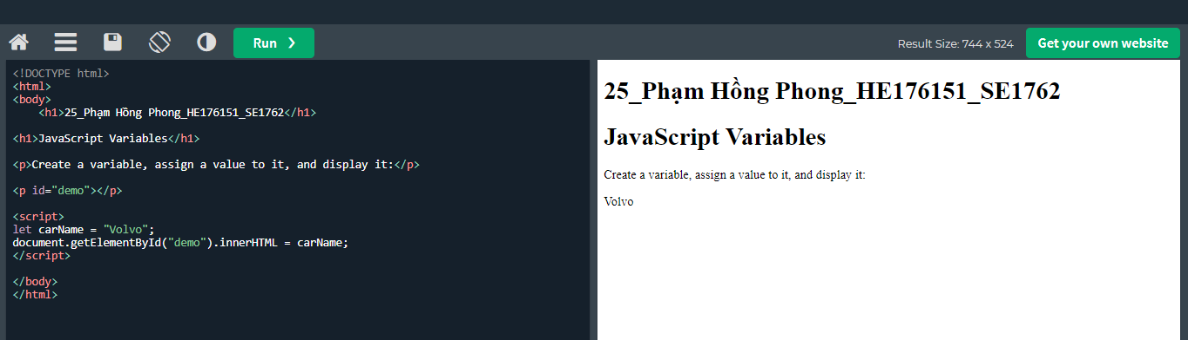

It's a good programming practice to declare all variables at the beginning of a script.

## Value = undefined

In computer programs, variables are often declared without a value. The value can be something that has to be calculated, or something that will be provided later, like user input.

A variable declared without a value will have the value undefined.

The variable carName will have the value undefined after the execution of this statement:

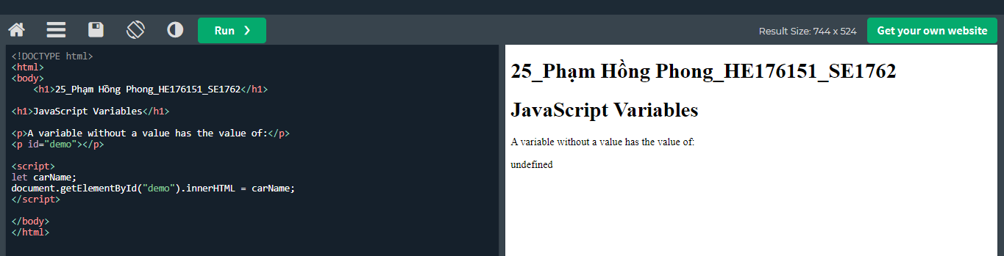

## Re-Declaring JavaScript Variables

If you re-declare a JavaScript variable declared with var, it will not lose its value.

The variable carName will still have the value "Volvo" after the execution of these statements:

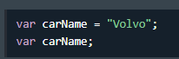

Ko bị mất giá trị khi khai báo lại

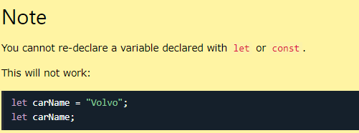

If you put a number in quotes, the rest of the numbers will be treated as strings, and concatenated.

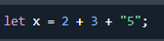 -> Kết quả là 55

## JavaScript Dollar Sign $

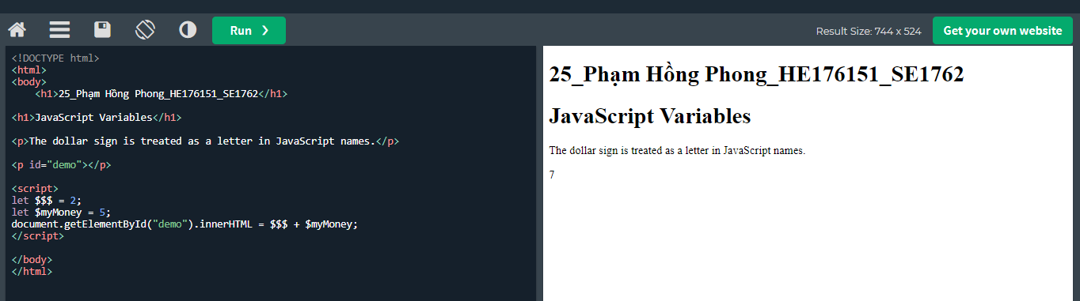

Việc sử dụng ký hiệu đô la không phổ biến lắm trong JavaScript, nhưng các lập trình viên chuyên nghiệp thường sử dụng nó làm bí danh cho hàm chính trong thư viện JavaScript.

Ví dụ: trong thư viện JavaScript jQuery, hàm chính $ được sử dụng để chọn các phần tử HTML. Trong jQuery $("p"); có nghĩa là "chọn tất cả các phần tử p".

## JavaScript Underscore (_)

Việc sử dụng dấu gạch dưới không phổ biến lắm trong JavaScript, nhưng một quy ước giữa các lập trình viên chuyên nghiệp là sử dụng nó làm bí danh cho các biến "riêng tư (ẩn)".

# JS Let, var

The let keyword was introduced in ES6 (2015)

## Let cannot be Redeclared

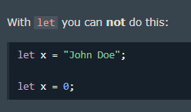

## Let must be Declared before use

## Let have Block Scope

These two keywords provide Block Scope in JavaScript.

Variables declared inside a { } block cannot be accessed from outside the block:

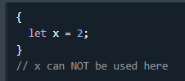

Variables declared with the var keyword can NOT have block scope.

Variables declared inside a { } block can be accessed from outside the block.

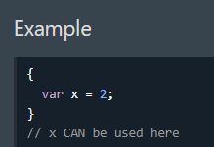

## Redeclaring

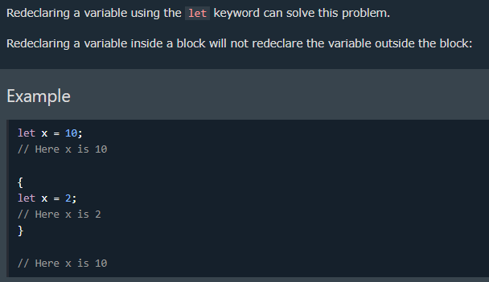

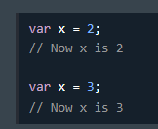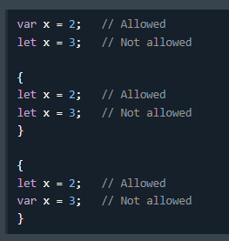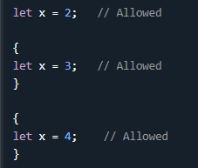

What is Good?

* let and const have block scope.
* let and const can not be redeclared.
* let and const must be declared before use.
* let and const does not bind to this.
* let and const are not hoisted.

What is Not Good?

* var does not have to be declared.
* var is hoisted.
* var binds to this.

## Let Hoisting

Các biến được xác định bằng var được đưa lên trên cùng và có thể được khởi tạo bất kỳ lúc nào.

Ý nghĩa: Bạn có thể sử dụng biến trước khi nó được khai báo:

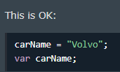

Các biến được xác định bằng let cũng được đưa lên đầu khối nhưng không được khởi tạo.

Ý nghĩa: Sử dụng biến let trước khi nó được khai báo sẽ dẫn đến lỗi ReferenceError:

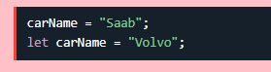

# JS const

The const keyword was introduced in ES6 (2015)

Variables defined with const cannot be Redeclared

Variables defined with const cannot be Reassigned

Variables defined with const have Block Scope

## Cannot be Reassigned

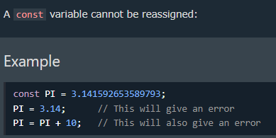

## Must be Assigned

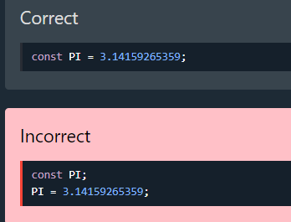

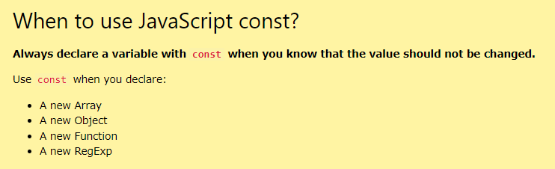

## Constant Objects and Arrays

The keyword const is a little misleading.

It does not define a constant value. It defines a constant reference to a value.

Because of this you can NOT:

* Reassign a constant value
* Reassign a constant array
* Reassign a constant object

But you CAN:

* Change the elements of constant array
* Change the properties of constant object

Constants Arrays

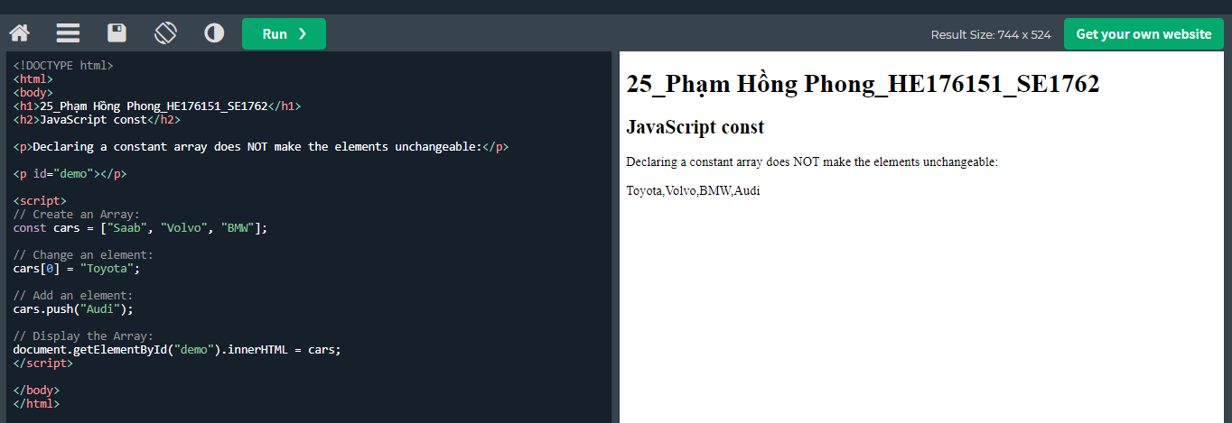

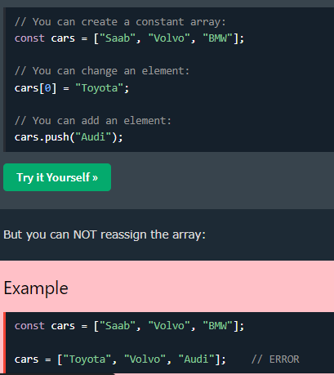

Tương tự với Object

What is Good?

* let and const have block scope.
* let and const can not be redeclared.
* let and const must be declared before use.
* let and const does not bind to this.
* let and const are not hoisted.

What is Not Good?

* var does not have to be declared.
* var is hoisted.
* var binds to this.

## Block Scope

Declaring a variable with const is similar to let when it comes to Block Scope.

The x declared in the block, in this example, is not the same as the x declared outside the block:

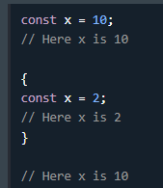

## Redeclaring

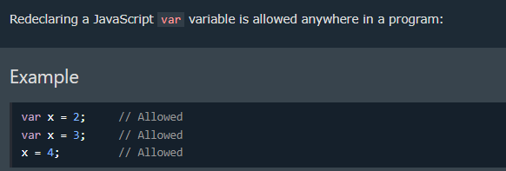

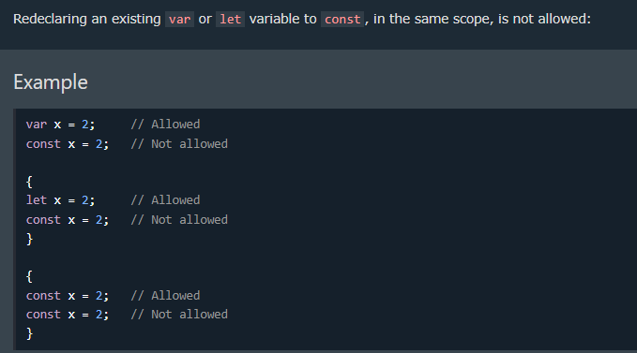

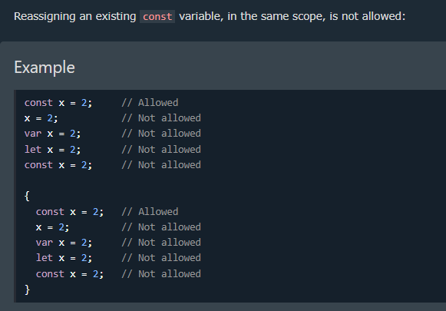

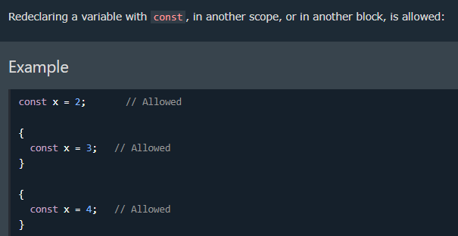

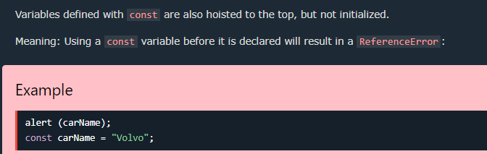

# JS Operators

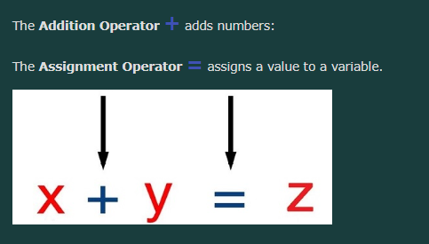

Types of JavaScript Operators

There are different types of JavaScript operators:

* Arithmetic Operators
* Assignment Operators
* Comparison Operators
* String Operators
* Logical Operators
* Bitwise Operators
* Ternary Operators
* Type Operators

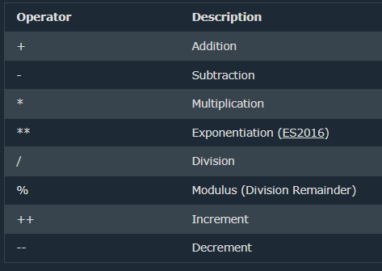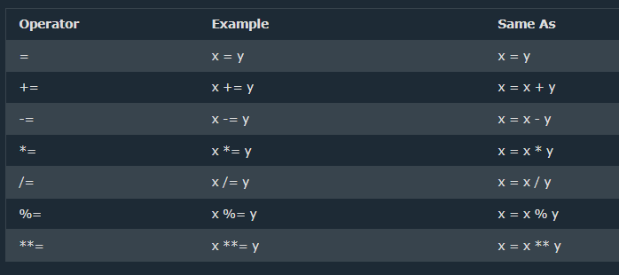

JS Comparison Operators

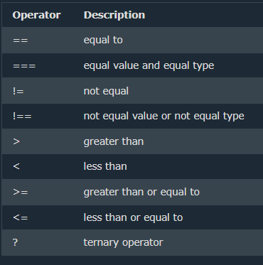

# JS Arithmetic Operators

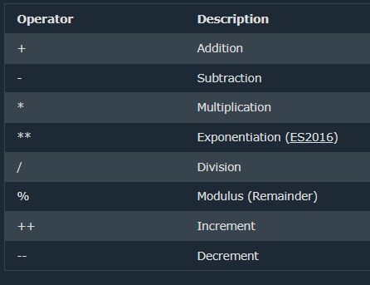

The exponentiation operator (**) raises the first operand to the power of the second operand.

# JS Data Types

## JavaScript has 8 Data Types

1. String  
2. Number  
3. Bigint  
4. Boolean  
5. Undefined  
6. Null  
7. Symbol  
8. Object

## The Object Data Type

The object data type can contain:

1. An object  
2. An array  
3. A date

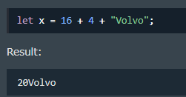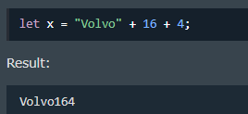

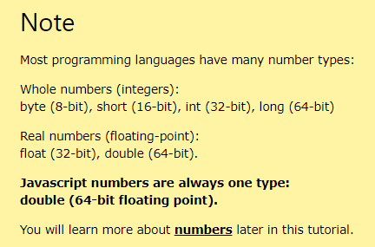

## JavaScript BigInt

All JavaScript numbers are stored in a a 64-bit floating-point format

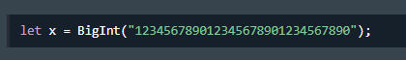

## JS Booleans

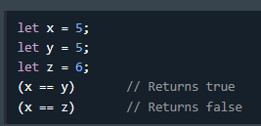

## JS typeof Operator

You can use the JavaScript typeof operator to find the type of a JavaScript variable.

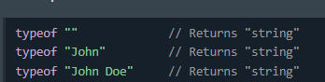

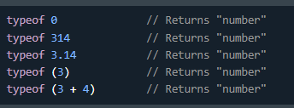

# JS Functions

A JavaScript function is a block of code designed to perform a particular task.

A JavaScript function is executed when "something" invokes it (calls it).

## Functions Syntax

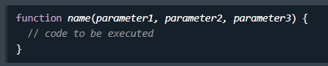

## Function Invocation

The code inside the function will execute when "something" invokes (calls) the function:

* When an event occurs (when a user clicks a button)
* When it is invoked (called) from JavaScript code
* Automatically (self invoked)

## Function Return

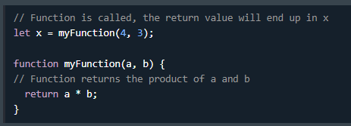

## Why Functions?

With functions you can reuse code

You can write code that can be used many times.

You can use the same code with different arguments, to produce different results.

## The () Operator

The () operator invokes (calls) the function

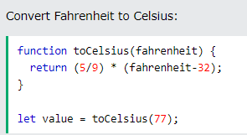

As you see from the examples above, toCelsius refers to the function object, and toCelsius() refers to the function result.

# JavaScript Objects

## Accessing Object Properties

* *objectName.propertyName*
* *objectName["propertyName"]*

Object Methods

* Objects can also have **methods**.
* Methods are **actions** that can be performed on objects.
* Methods are stored in properties as **function definitions**.

A method is a function stored as a property.

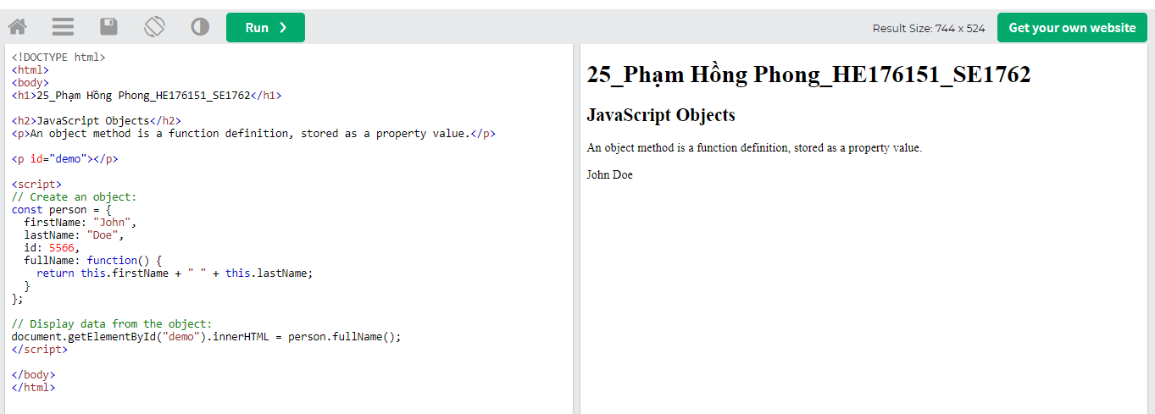

If you access a method **without** the () parentheses, it will return the **function definition**

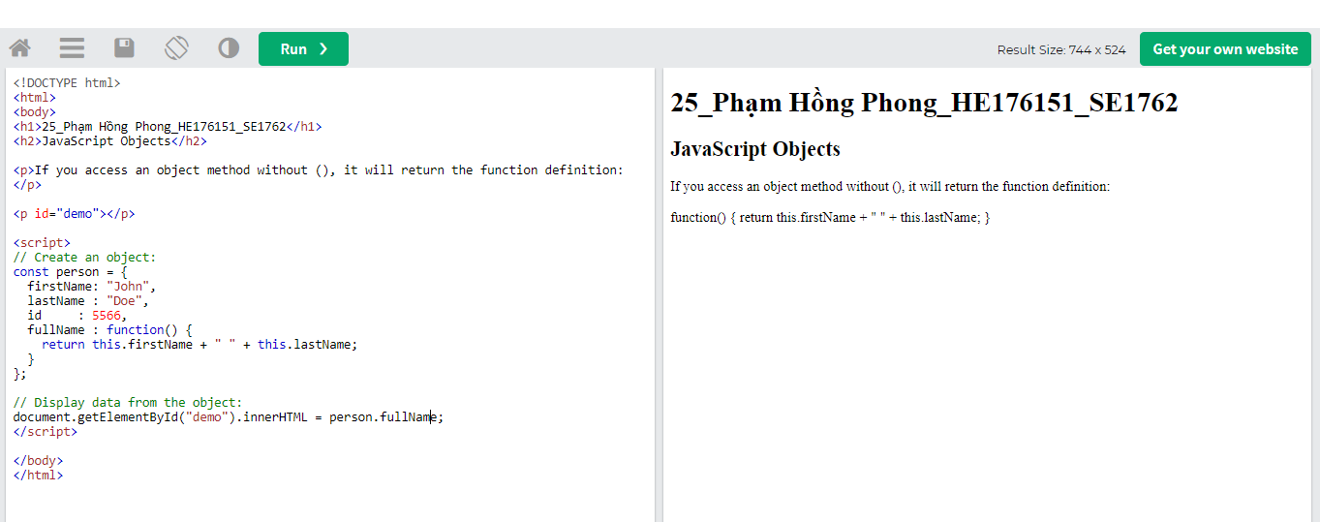

# JSEvent

HTML events are **"things"** that happen to HTML elements.

When JavaScript is used in HTML pages, JavaScript can **"react"** to these events.

An HTML event can be something the browser does, or something a user does.

Here are some examples of HTML events:

* An HTML web page has finished loading
* An HTML input field was changed
* An HTML button was clicked

JavaScript code is often several lines long. It is more common to see event attributes calling functions:

## JavaScript Event Handlers

Event handlers can be used to handle and verify user input, user actions, and browser actions:

* Things that should be done every time a page loads
* Things that should be done when the page is closed
* Action that should be performed when a user clicks a button
* Content that should be verified when a user inputs data

Many different methods can be used to let JavaScript work with events:

* HTML event attributes can execute JavaScript code directly
* HTML event attributes can call JavaScript functions
* You can assign your own event handler functions to HTML elements
* You can prevent events from being sent or being handled
* And more ...

# JS Strings

## JavaScript strings are for storing and manipulating text.

A JavaScript string is zero or more characters written inside quotes.

String Length

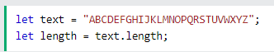

## Escape Character

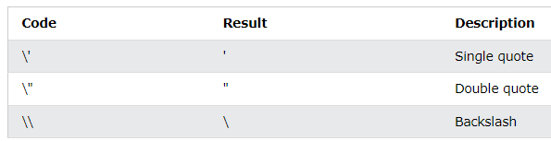

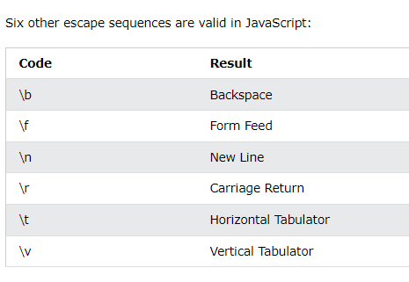

Comparing two JavaScript objects **always** returns **false**.

# JS String Methods

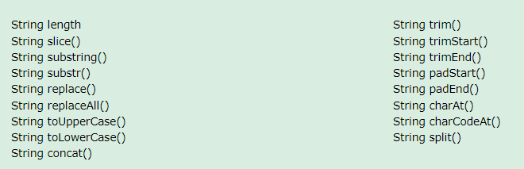

Demo các hàm:

<https://www.w3schools.com/js/js_string_methods.asp>

# JS String Search

* String indexOf()
* String lastIndexOf()
* String search()
* String match()
* String matchAll()
* String includes()
* String startsWith()
* String endsWith()

JavaScript counts positions from zero.

0 is the first position in a string, 1 is the second, 2 is the third, ...

# JS String Templates

Synonyms:

* Template Literals
* Template Strings
* String Templates
* Back-Tics Syntax

## Back-Tics Syntax

Template Literals use back-ticks (``) rather than the quotes ("") to define a string

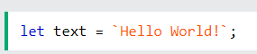

## Quotes Inside Strings

With template literals, you can use both single and double quotes inside a string

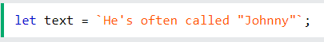

## Multiline Strings

Template literals allows multiline strings

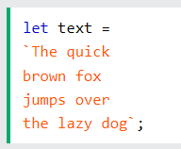

## Interpolation

Template literals provide an easy way to interpolate variables and expressions into strings.

The method is called string interpolation.

Syntax:

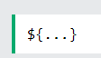

## Variable Substitutions

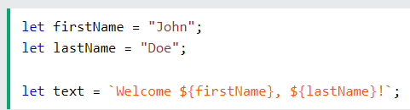

Automatic replacing of variables with real values is called string interpolation.

## Expression Substitution

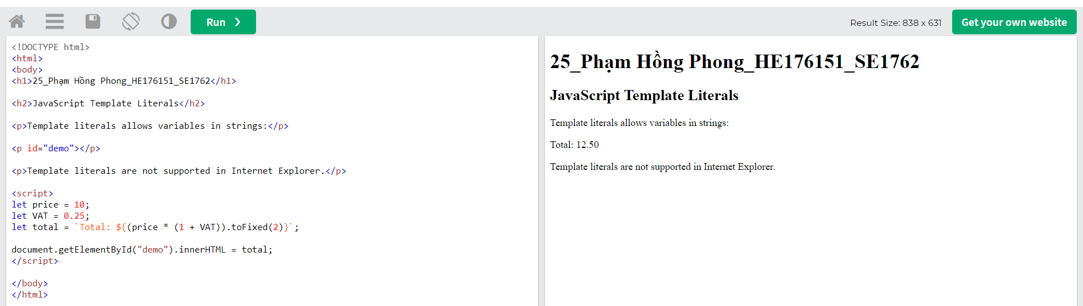

Automatic replacing of expressions with real values is called string interpolation.

## HTML Templates

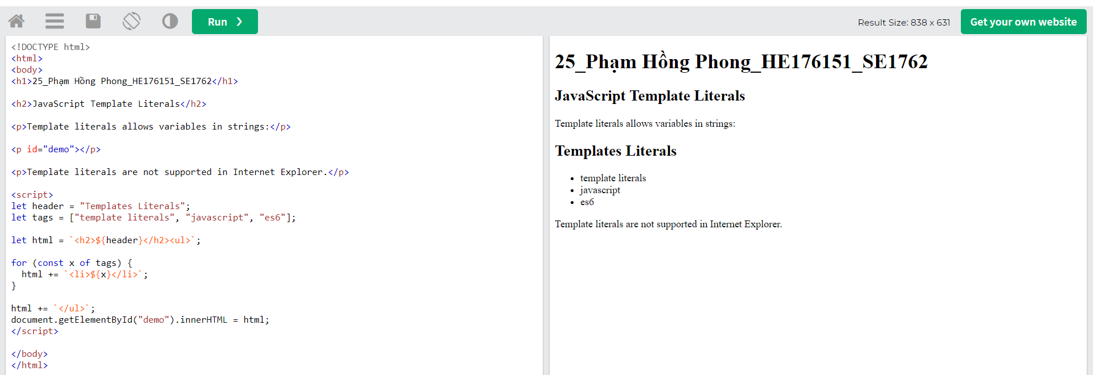

# 

# JS Numbers

WARNING !!

JavaScript uses the + operator for both addition and concatenation.

Numbers are added. Strings are concatenated.

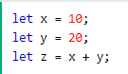 -> z = 30

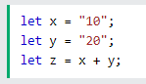-> z = 1020

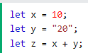->z = 1020

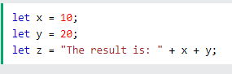-> z = 1020

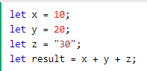->z = 3030

The JavaScript interpreter works from left to right.

First 10 + 20 is added because x and y are both numbers.

Then 30 + "30" is concatenated because z is a string.

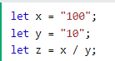 -> z = 10

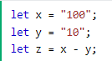-> z = 90

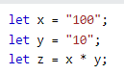-> x = 1000

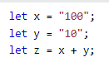->z = 10010

## NaN - Not a Number

NaN is a JavaScript reserved word indicating that a number is not a legal number.

Trying to do arithmetic with a non-numeric string will result in NaN (Not a Number):

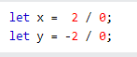

x = infinity

y = - infinity

Infinity is a number: typeof Infinity returns number.

Do not create Number objects.

The new keyword complicates the code and slows down execution speed.

Number Objects can produce unexpected results:

Comparing two JavaScript objects **always** returns **false**.

# JS BigInt

The JavaScript typeof a BigInt is "bigint"

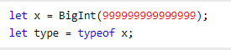 type = bigint

BigInt is the second numeric data type in JavaScript (after Number).

With BigInt the total number of supported data types in JavaScript is 8:

1. String  
2. Number  
3. Bigint  
4. Boolean  
5. Undefined  
6. Null  
7. Symbol  
8. Object

Arithmetic between a BigInt and a Number is not allowed (type conversion lose information).

Unsigned right shift (>>>) can not be done on a BigInt (it does not have a fixed width).

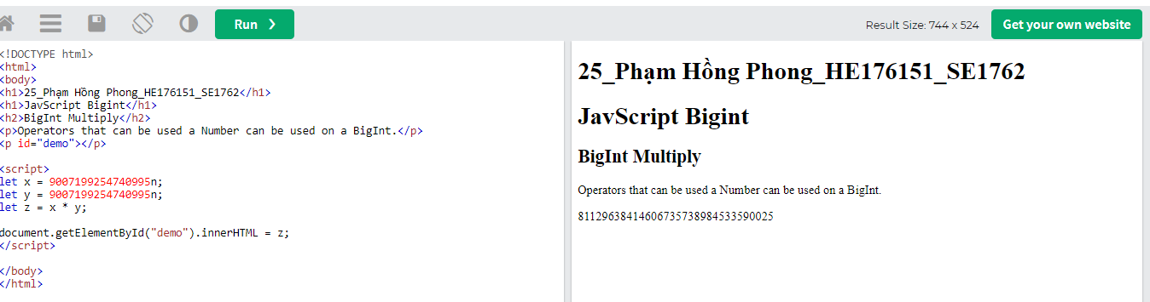

# JS Number Methods

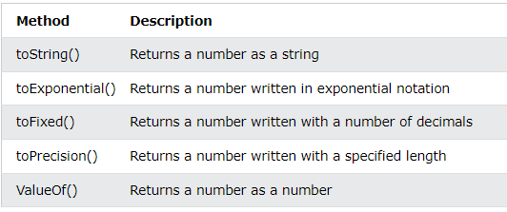

<https://www.w3schools.com/js/js_number_methods.asp>

All JavaScript data types have a valueOf() and a toString() method.

Converting Variables

The methods above are not **number** methods. They are **global** JavaScript methods.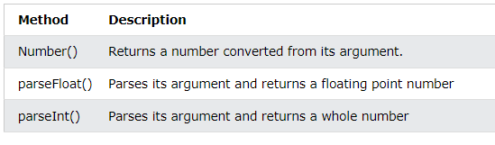

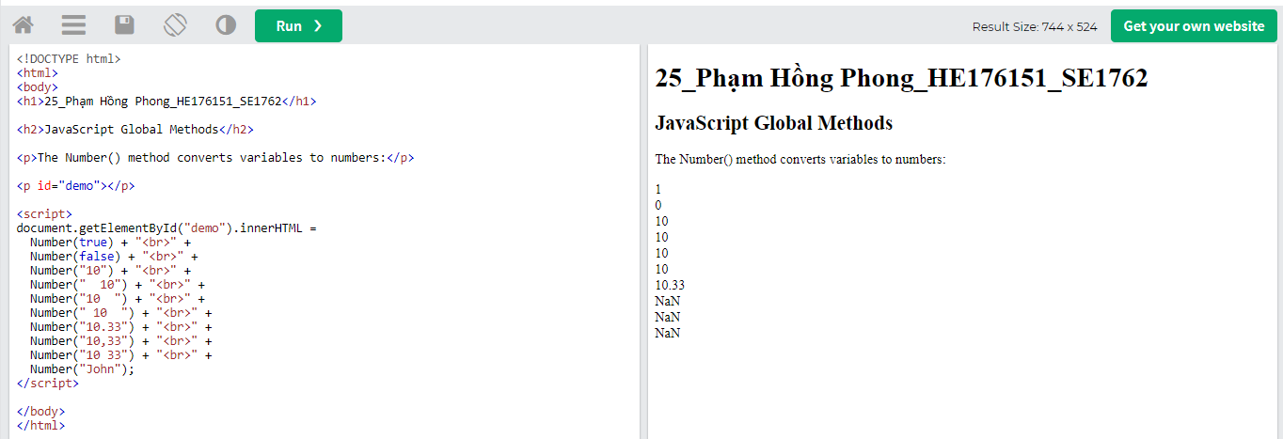

## The Number() Method Used on Dates

Number() can also convert a date to a number.

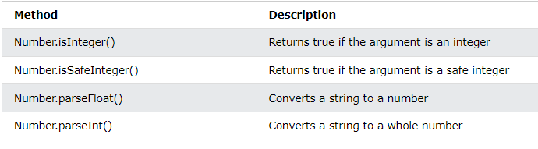

## Number Methods Cannot be Used on Variables

The number methods above belong to the JavaScript **Number Object**.

These methods can only be accessed like Number.isInteger().

Using X.isInteger() where X is a variable, will result in an error:

TypeError X.isInteger is not a function.

# JS Number Properties

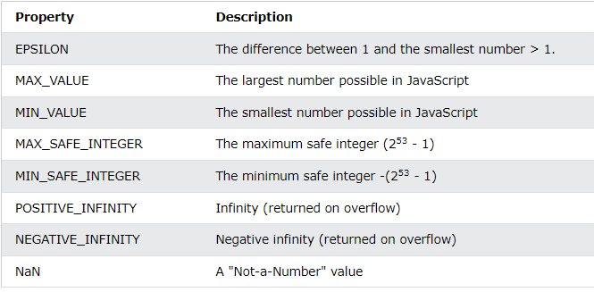

# JS Arrays

## Creating an Array

Using an array literal is the easiest way to create a JavaScript Array.

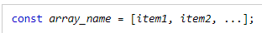

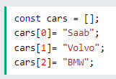

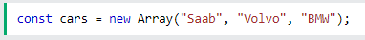

## Changing an Array Element

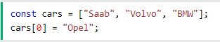

## Converting an Array to a String

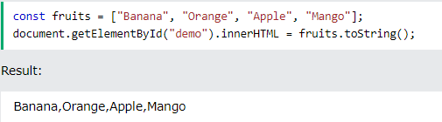

## The Difference Between Arrays and Objects

In JavaScript, **arrays** use **numbered indexes**.

In JavaScript, **objects** use **named indexes**.

Arrays are a special kind of objects, with numbered indexes.

## When to Use Arrays. When to use Objects.

* JavaScript does not support associative arrays.
* You should use **objects** when you want the element names to be **strings (text)**.
* You should use **arrays** when you want the element names to be **numbers**.

## JavaScript new Array()

JavaScript has a built-in array constructor new Array().

But you can safely use [] instead.

# JS Array Methods

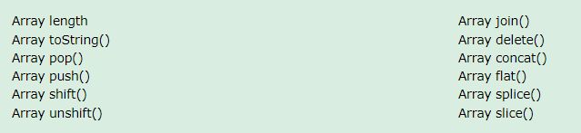

[**https://www.w3schools.com/js/js_array_methods.asp**](https://www.w3schools.com/js/js_array_methods.asp)

# JS Array Sort

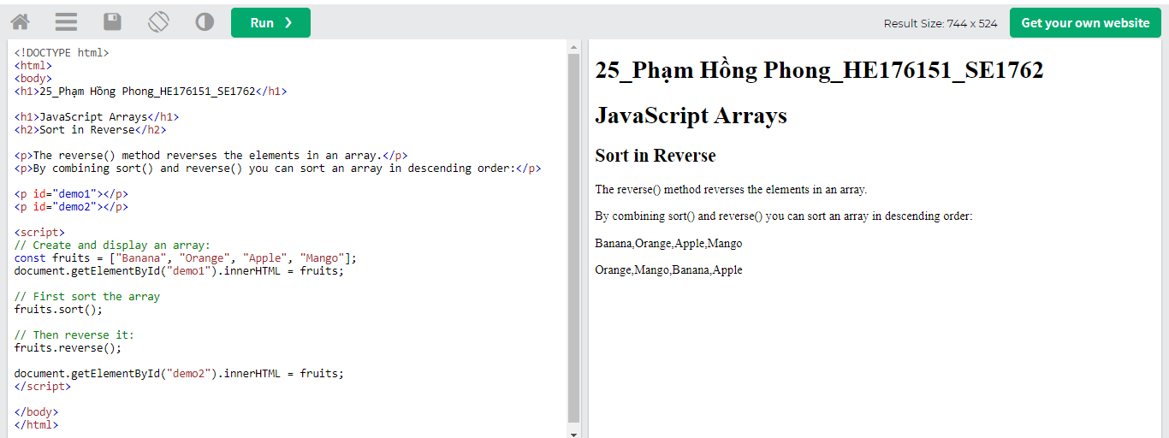

The sort() method sorts an array alphabetically

The reverse() method reverses the elements in an array.

# JS Array Iteration

Array iteration methods operate on every array item.

The forEach() method calls a function (a callback function) once for each array element.

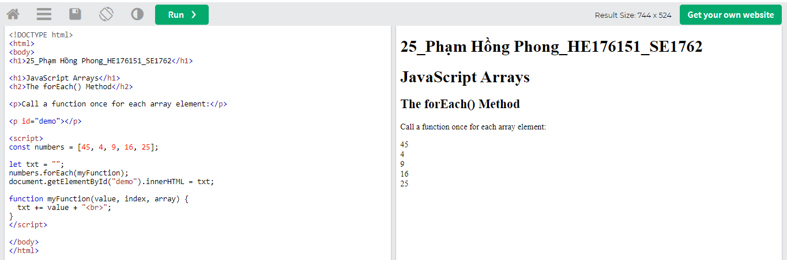

Note that the function takes 3 arguments:

* The item value
* The item index
* The array itself

## JavaScript Array map()

The map() method creates a new array by performing a function on each array element.

The map() method does not execute the function for array elements without values.

The map() method does not change the original array.

## JavaScript Array reduce()

The reduce() method runs a function on each array element to produce (reduce it to) a single value.

The reduce() method works from left-to-right in the array. See also reduceRight().

The reduce() method does not reduce the original array.

## JavaScript Array filter()

The filter() method creates a new array with array elements that pass a test.

## JavaScript Array reduceRight()

The reduceRight() method runs a function on each array element to produce (reduce it to) a single value.

The reduceRight() works from right-to-left in the array. See also reduce().

The reduceRight() method does not reduce the original array.

## JavaScript Array every()

The every() method checks if all array values pass a test.

## JavaScript Array some()

The some() method checks if some array values pass a test.

## JavaScript Array indexOf()

The indexOf() method searches an array for an element value and returns its position.

## JavaScript Array lastIndexOf()

Array.lastIndexOf() is the same as Array.indexOf(), but returns the position of the last occurrence of the specified element.

## JavaScript Array find()

The find() method returns the value of the first array element that passes a test function.

## JavaScript Array.from()

The Array.from() method returns an Array object from any object with a length property or any iterable object.

## JavaScript Array Keys()

The Array.keys() method returns an Array Iterator object with the keys of an array

# JS Array Const

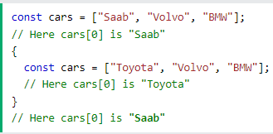

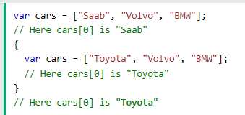

Redeclaring an array with const, in another scope, or in another block, is allowed:

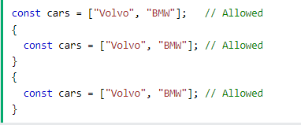

# JS Dates

# 

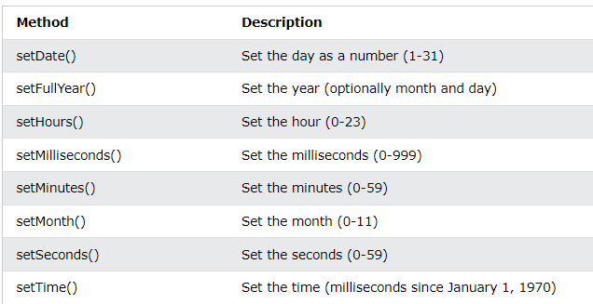

# JS Math

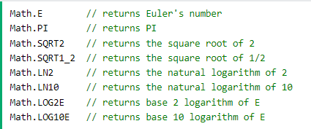

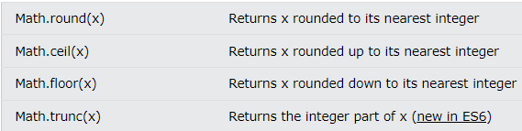

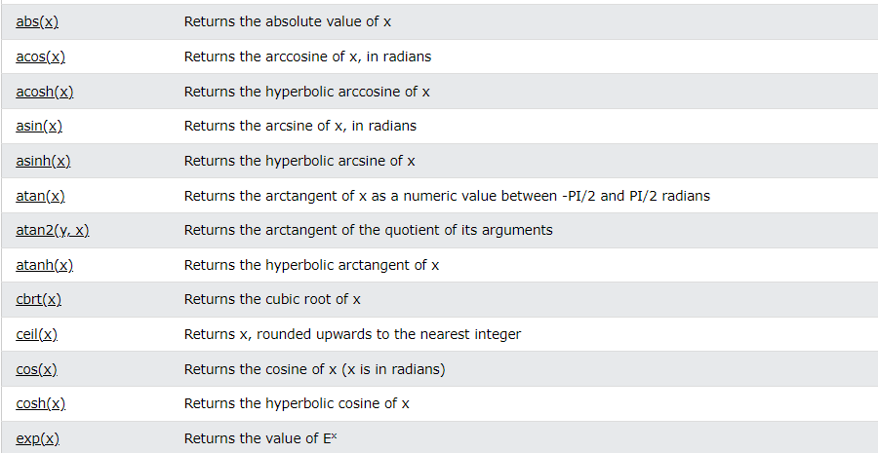

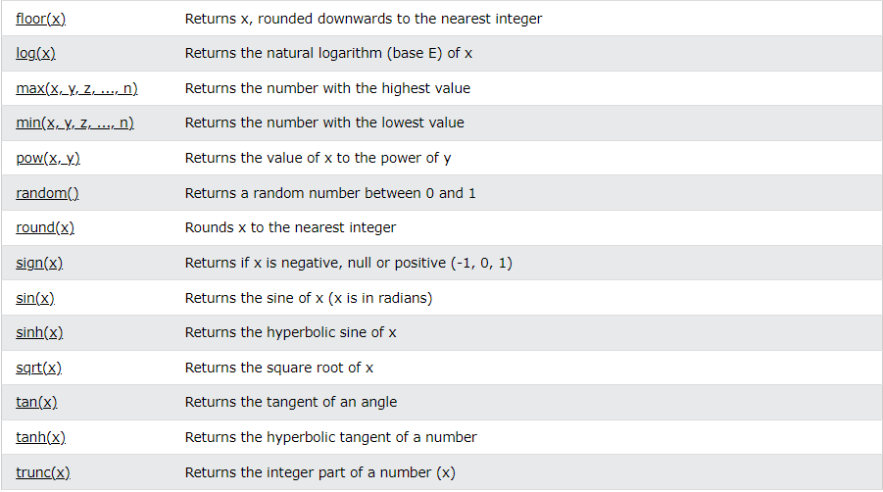

# JS Random

## Math.random()

Math.random() returns a random number between 0 (inclusive), and 1 (exclusive):

Math.random() always returns a number lower than 1.

# JS Booleans

A JavaScript Boolean represents one of two values: **true** or **false**.

Very often, in programming, you will need a data type that can only have one of two values, like

* YES / NO
* ON / OFF
* TRUE / FALSE

For this, JavaScript has a **Boolean** data type. It can only take the values **true** or **false**.

# JS Comparisons

Toán tử 3 ngôi 👍

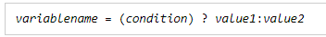

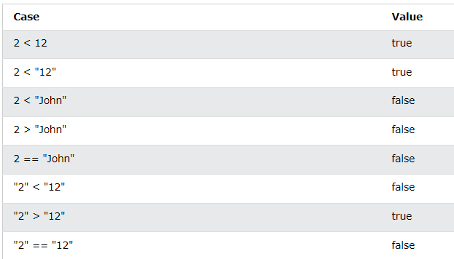When comparing two strings, "2" will be greater than "12", because (alphabetically) 1 is less than 2.

## The Nullish Coalescing Operator (??)

The ?? operator returns the first argument if it is not **nullish** (null or undefined).

Otherwise it returns the second argument.

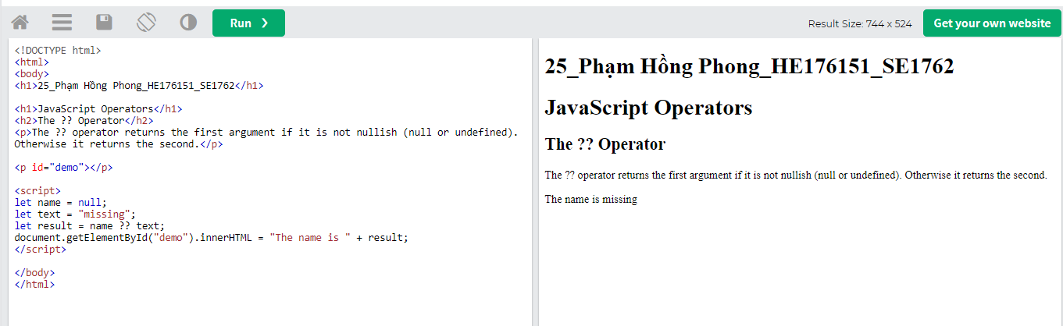

## The Optional Chaining Operator (?.)

The ?. operator returns undefined if an object is undefined or null (instead of throwing an error).

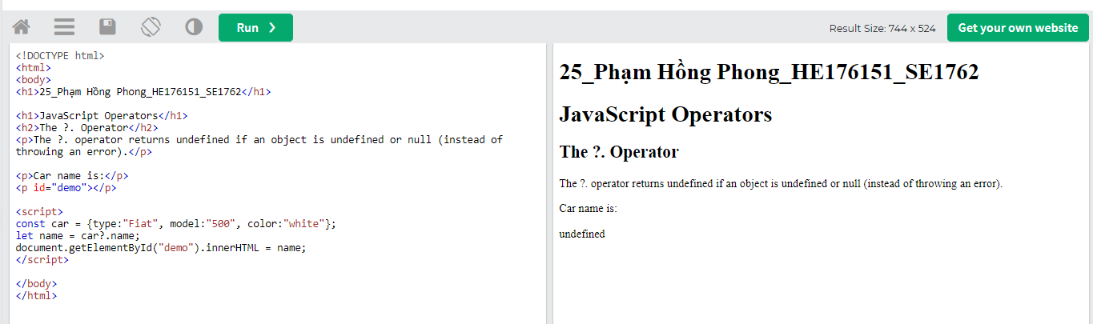

# JS If Else

## Conditional Statements

Very often when you write code, you want to perform different actions for different decisions.

You can use conditional statements in your code to do this.

In JavaScript we have the following conditional statements:

* Use if to specify a block of code to be executed, if a specified condition is true
* Use else to specify a block of code to be executed, if the same condition is false
* Use else if to specify a new condition to test, if the first condition is false
* Use switch to specify many alternative blocks of code to be executed

# JS Switch

# The switch statement is used to perform different actions based on different conditions.

## The JavaScript Switch Statement

Use the switch statement to select one of many code blocks to be executed.

This is how it works:

* The switch expression is evaluated once.
* The value of the expression is compared with the values of each case.
* If there is a match, the associated block of code is executed.
* If there is no match, the default code block is executed.

The break Keyword

When JavaScript reaches a break keyword, it breaks out of the switch block.

This will stop the execution inside the switch block.

It is not necessary to break the last case in a switch block. The block breaks (ends) there anyway.

The default Keyword

The default keyword specifies the code to run if there is no case match:

# JS Loop For

Loops can execute a block of code a number of times.

## JavaScript Loops

Loops are handy, if you want to run the same code over and over again, each time with a different value.

## Different Kinds of Loops

JavaScript supports different kinds of loops:

* for - loops through a block of code a number of times
* for/in - loops through the properties of an object
* for/of - loops through the values of an iterable object
* while - loops through a block of code while a specified condition is true
* do/while - also loops through a block of code while a specified condition is true

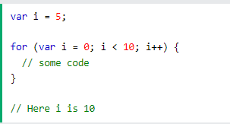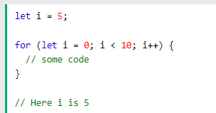

# JS Loop For In

## The For In Loop

The JavaScript for in statement loops through the properties of an Object

Syntax

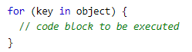

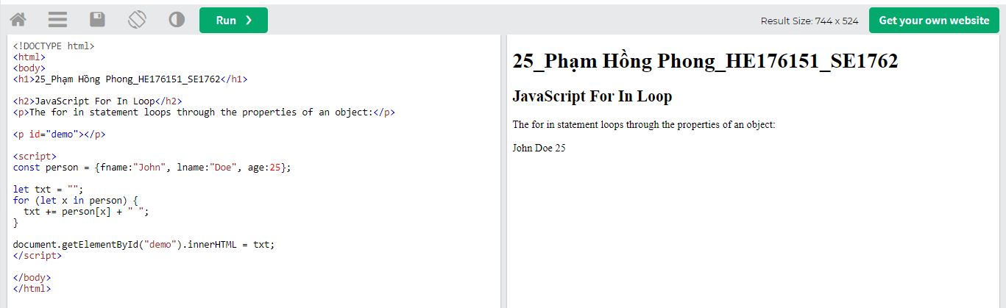The **for in** loop iterates over a **person** object

* Each iteration returns a **key** (x)
* The key is used to access the **value** of the key
* The value of the key is **person[x]**

Do not use **for in** over an Array if the index **order** is important.

The index order is implementation-dependent, and array values may not be accessed in the order you expect.

It is better to use a **for** loop, a **for of** loop, or **Array.forEach()** when the order is important.

# JS Loop For Of

## The For Of Loop

The JavaScript for of statement loops through the values of an iterable object.

It lets you loop over iterable data structures such as Arrays, Strings, Maps, NodeLists, and more:

Syntax:

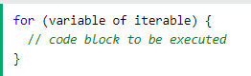

**variable** - For every iteration the value of the next property is assigned to the variable. *Variable* can be declared with const, let, or var.

**iterable** - An object that has iterable properties.

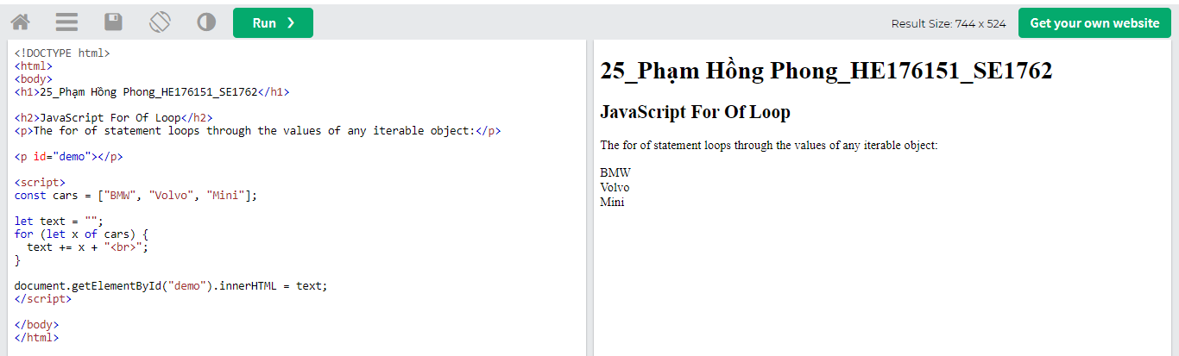

# JS Loop While

Loops can execute a block of code as long as a specified condition is true.

## The While Loop

The while loop loops through a block of code as long as a specified condition is true

Syntax:

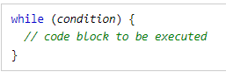

## The Do While Loop

The do while loop is a variant of the while loop. This loop will execute the code block once, before checking if the condition is true, then it will repeat the loop as long as the condition is true.

Syntax:

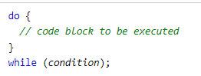

# JS Break

The continue statement (with or without a label reference) can only be used to **skip one loop iteration**.

The break statement, without a label reference, can only be used to **jump out of a loop or a switch**.

With a label reference, the break statement can be used to **jump out of any code block**:

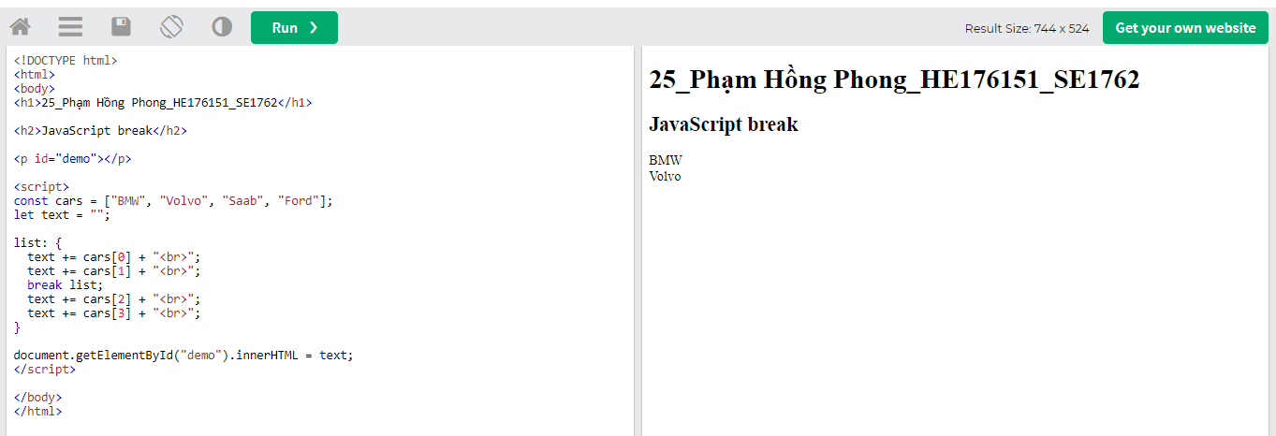

A code block is a block of code between { and }.

# JS Iterables

Iterables are iterable objects (like Arrays).

Iterables can be accessed with simple and efficient code.

Iterables can be iterated over with for..of loops

## The For Of Loop

The JavaScript for..of statement loops through the elements of an iterable object.

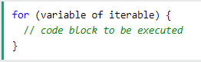

Iterating is easy to understand.

It simply means looping over a sequence of elements.

Here are some easy examples:

* Iterating over a String

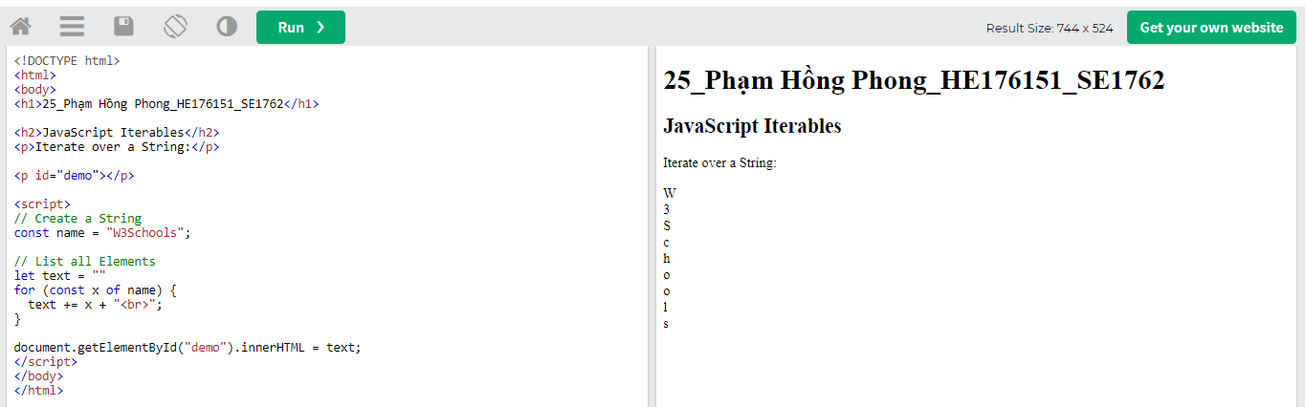

* Iterating over an Array

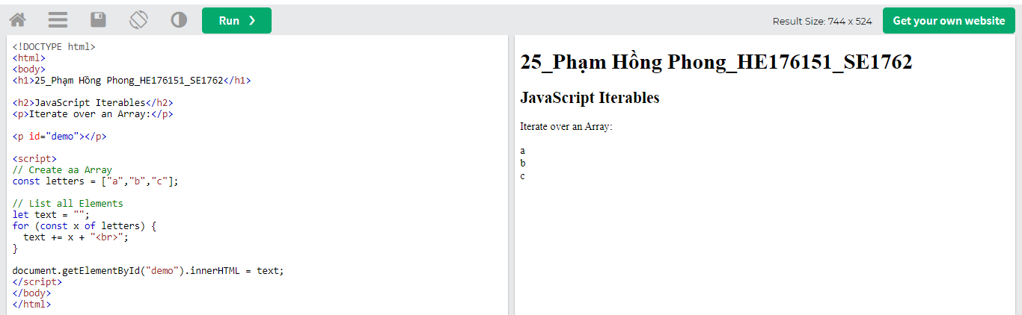

# JS Sets

A JavaScript Set is a collection of unique values.

Each value can only occur once in a Set.

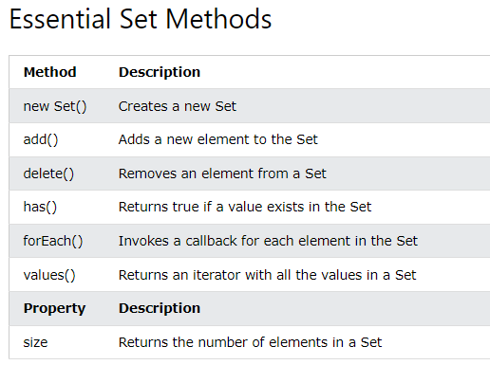

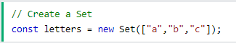

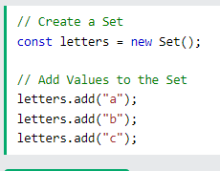

**Add values**

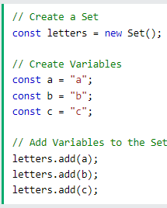

**Add variable**

## The values() Method

The values() method returns a new iterator object containing all the values in a Set:

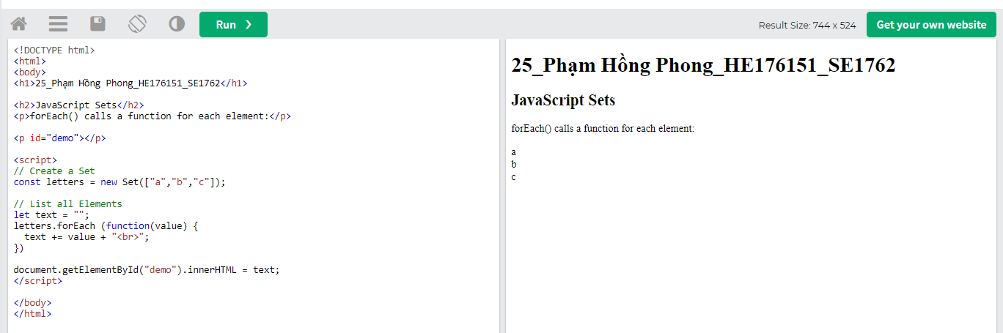

# JS Maps

A Map holds key-value pairs where the keys can be any datatype.

A Map remembers the original insertion order of the keys.

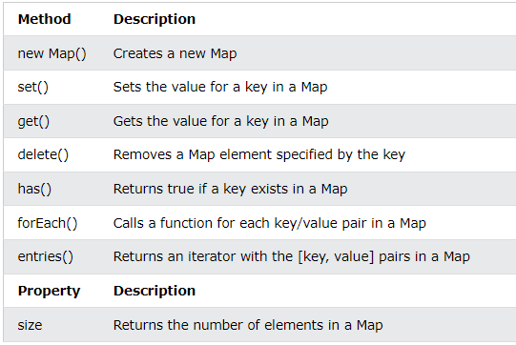

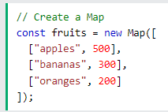

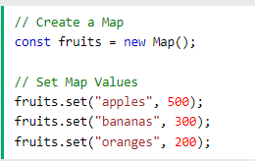

## The get() Method

The get() method gets the value of a key in a Map:

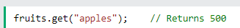

## The size Property

The size property returns the number of elements in a Map:

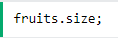

## The delete() Method

The delete() method removes a Map element:

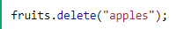

## The has() Method

The has() method returns true if a key exists:

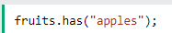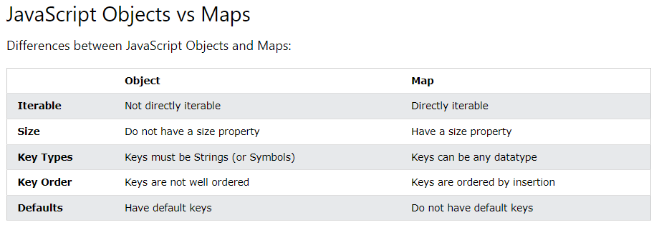 in a Map

# JS Typeof

In JavaScript there are 5 different data types that can contain values:

* string
* number
* boolean
* object
* function

There are 6 types of objects:

* Object
* Date
* Array
* String
* Number
* Boolean

And 2 data types that cannot contain values:

* null
* Undefined
* The data type of NaN is number
* The data type of an array is object
* The data type of a date is object
* The data type of null is object
* The data type of an undefined variable is **undefined** *
* The data type of a variable that has not been assigned a value is also **undefined** *

You cannot use typeof to determine if a JavaScript object is an array (or a date).

Undefined And Null

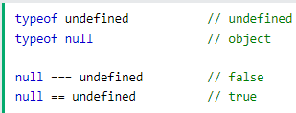

# 

# JS Bitwise

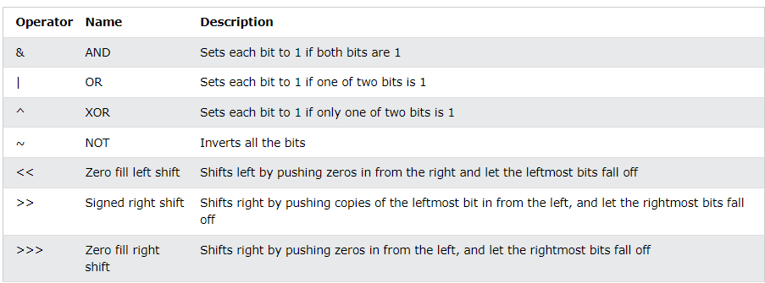

# JS RegExp

<https://www.w3schools.com/js/js_regexp.asp>

# 

# JS Errors

## Throw, and Try...Catch...Finally

The try statement defines a code block to run (to try).

The catch statement defines a code block to handle any error.

The finally statement defines a code block to run regardless of the result.

The throw statement defines a custom error.

JavaScript catches **adddlert** as an error, and executes the catch code to handle it.

## JavaScript try and catch

The try statement allows you to define a block of code to be tested for errors while it is being executed.

The catch statement allows you to define a block of code to be executed, if an error occurs in the try block.

## JavaScript Throws Errors

When an error occurs, JavaScript will normally stop and generate an error message.

The technical term for this is: JavaScript will **throw an exception (throw an error)**.

JavaScript will actually create an **Error object** with two properties: **name** and **message**.

## The throw Statement

The throw statement allows you to create a custom error.

Technically you can **throw an exception (throw an error)**.

The exception can be a JavaScript String, a Number, a Boolean or an Object:

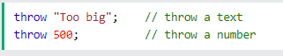

# JS Scope

Scope determines the accessibility (visibility) of variables.

JavaScript has 3 types of scope:

* Block scope
* Function scope
* Global scope

## Block Scope

Before ES6 (2015), JavaScript had only **Global Scope** and **Function Scope**.

ES6 introduced two important new JavaScript keywords: let and const.

These two keywords provide **Block Scope** in JavaScript.

Variables declared inside a { } block cannot be accessed from outside the block:

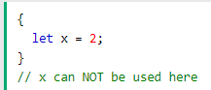

Variables declared with the var keyword can NOT have block scope.

Variables declared inside a { } block can be accessed from outside the block.

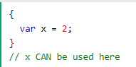

A global variable has **Global Scope**:

All scripts and functions on a web page can access it.

## Automatically Global

If you assign a value to a variable that has not been declared, it will automatically become a **GLOBAL** variable.

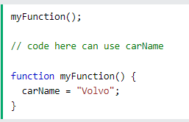

# JS Hoisting

Hoisting is JavaScript's default behavior of moving declarations to the top.

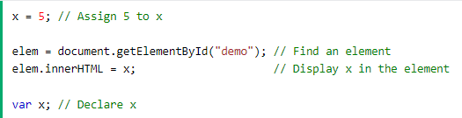

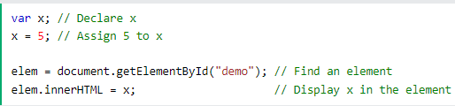

2 ví dụ cùng cho 1 kết quả

## The let and const Keywords

Variables defined with let and const are hoisted to the top of the block, but not *initialized*.

Meaning: The block of code is aware of the variable, but it cannot be used until it has been declared.

Using a let variable before it is declared will result in a ReferenceError

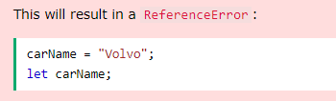

Using a const variable before it is declared, is a syntax error, so the code will simply not run.

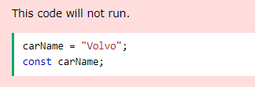

## JavaScript Initializations are Not Hoisted

JavaScript only hoists declarations, not initializations

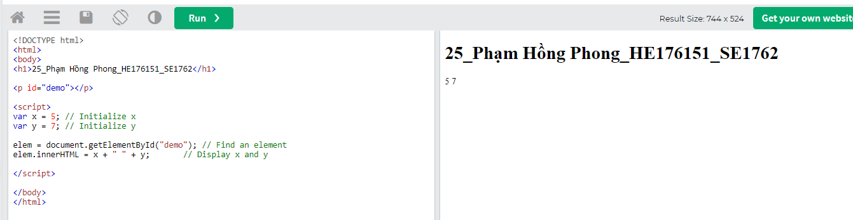

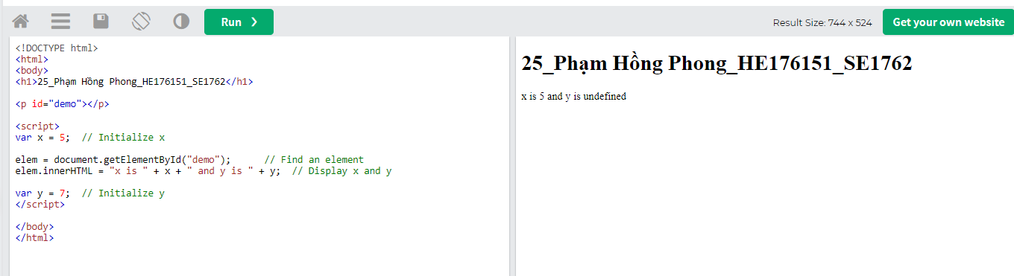

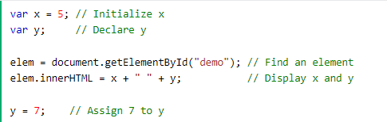

display : x=5; y = undefined

# JS this Keyword

In JavaScript, the this keyword refers to an **object**.

**Which** object depends on how this is being invoked (used or called).

The this keyword refers to different objects depending on how it is used:

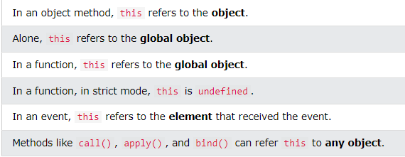

this is not a variable. It is a keyword. You cannot change the value of this.

# JS Arrow Function

Arrow functions allow us to write shorter function syntax: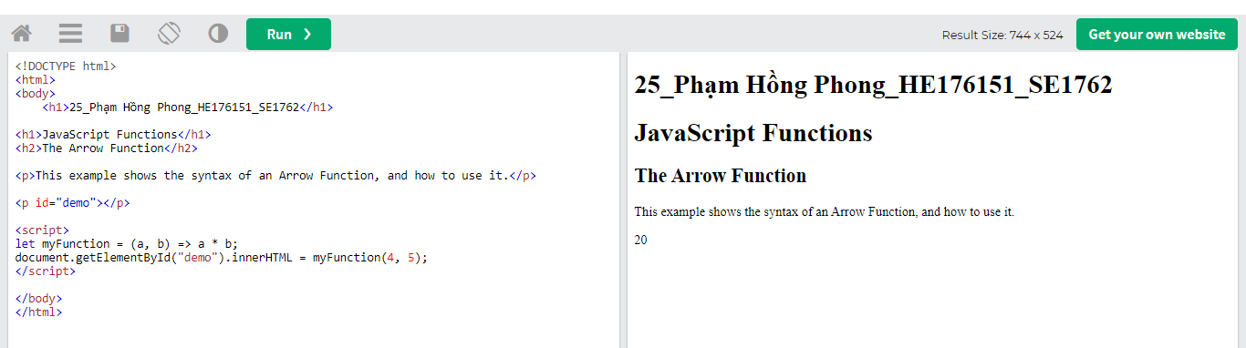

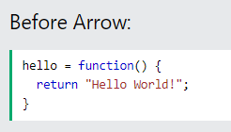 —> 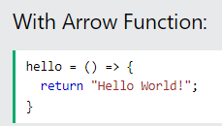

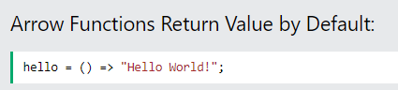

**Note:** This works only if the function has only one statement.

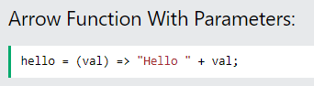

In fact, if you have only one parameter, you can skip the parentheses as well:

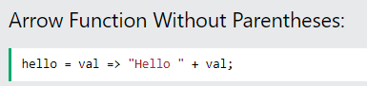

# 

# 

# JS JSON

JSON is a format for storing and transporting data.

JSON is often used when data is sent from a server to a web page.

## What is JSON?

* JSON stands for **J**ava**S**cript **O**bject **N**otation
* JSON is a lightweight data interchange format
* JSON is language independent **\***
* JSON is "self-describing" and easy to understand

* The JSON syntax is derived from JavaScript object notation syntax, but the JSON format is text only. Code for reading and generating JSON data can be written in any programming language.

# JS Debugging

Errors can (will) happen, every time you write some new computer code.

# 

# JS Best Practices

Avoid global variables, avoid new, avoid ==, avoid eval()

## Declarations on Top

It is a good coding practice to put all declarations at the top of each script or function.

This will:

* Give cleaner code
* Provide a single place to look for local variables
* Make it easier to avoid unwanted (implied) global variables
* Reduce the possibility of unwanted re-declarations

## Don't Use new Object()

* Use "" instead of new String()
* Use 0 instead of new Number()
* Use false instead of new Boolean()
* Use {} instead of new Object()
* Use [] instead of new Array()
* Use /()/ instead of new RegExp()
* Use function (){} instead of new Function()

## Initialize Variables

It is a good coding practice to initialize variables when you declare them.

This will:

* Give cleaner code
* Provide a single place to initialize variables
* Avoid undefined values

# JS Performance

## Reduce Activity in Loops

Loops are often used in programming.

Each statement in a loop, including the for statement, is executed for each iteration of the loop.

Statements or assignments that can be placed outside the loop will make the loop run faster.

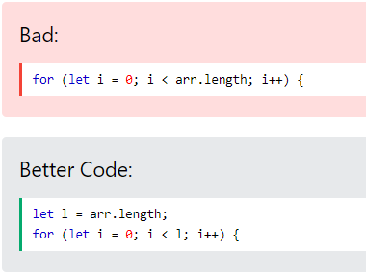

## Reduce DOM Access

Accessing the HTML DOM is very slow, compared to other JavaScript statements.

If you expect to access a DOM element several times, access it once, and use it as a local variable:

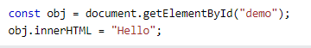

## Reduce DOM Size

Keep the number of elements in the HTML DOM small.

This will always improve page loading, and speed up rendering (page display), especially on smaller devices.

Every attempt to search the DOM (like getElementsByTagName) will benefit from a smaller DOM.

## Avoid Unnecessary Variables

Don't create new variables if you don't plan to save values.

Often you can replace code like this:

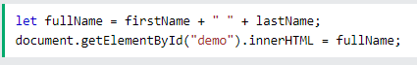

# 

# 

# 

JS Functions

# Function Definitions

JavaScript functions are **defined** with the function keyword.

You can use a function **declaration** or a function **expression**.

## Function Declarations

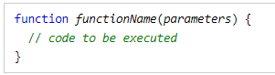

## Function Expressions

A JavaScript function can also be defined using an **expression**.

A function expression can be stored in a variable:

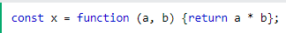

After a function expression has been stored in a variable, the variable can be used as a function:

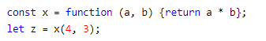

The function above is actually an **anonymous function** (a function without a name).

Functions stored in variables do not need function names. They are always invoked (called) using the variable name.

The function above ends with a semicolon because it is a part of an executable statement.

## Function() Constructor

As you have seen in the previous examples, JavaScript functions are defined with the function keyword.

Functions can also be defined with a built-in JavaScript function constructor called Function().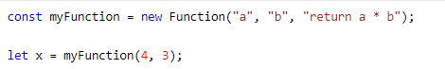

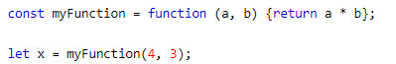

## Function Hoisting

Earlier in this tutorial, you learned about "hoisting" ([JavaScript Hoisting](https://www.w3schools.com/js/js_hoisting.asp)).

Hoisting is JavaScript's default behaviour of moving **declarations** to the top of the current scope.

Hoisting applies to variable declarations and to function declarations.

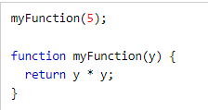

## Self-Invoking Functions

Function expressions can be made "self-invoking".

A self-invoking expression is invoked (started) automatically, without being called.

Function expressions will execute automatically if the expression is followed by ().

You cannot self-invoke a function declaration.

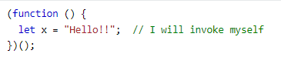

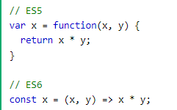

# Function Parameters

A JavaScript function does not perform any checking on parameter values (arguments).

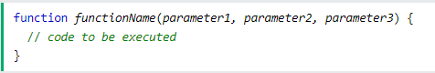

Function **parameters** are the **names** listed in the function definition.

Function **arguments** are the real **values** passed to (and received by) the function.

## Parameter Rules

JavaScript function definitions do not specify data types for parameters.

JavaScript functions do not perform type checking on the passed arguments.

JavaScript functions do not check the number of arguments received.

## Function Rest Parameter

The rest parameter (...) allows a function to treat an indefinite number of arguments as an array:

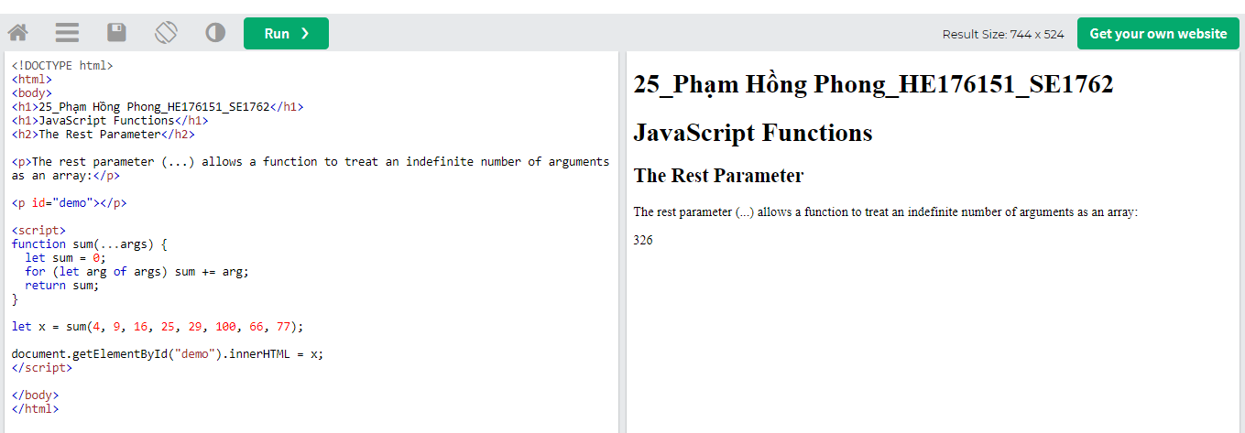

# Function Invocation

## Invoking a JavaScript Function

The code inside a function is not executed when the function is **defined**.

The code inside a function is executed when the function is **invoked**.

It is common to use the term "**call a function**" instead of "**invoke a function**".

It is also common to say "call upon a function", "start a function", or "execute a function".

In this tutorial, we will use **invoke**, because a JavaScript function can be invoked without being called.

## Invoking a Function with a Function Constructor

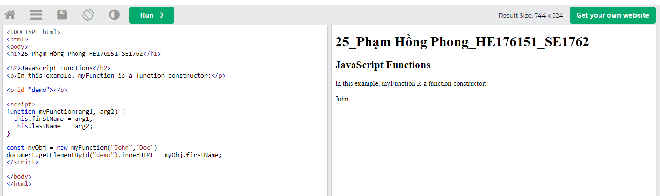

The this keyword in the constructor does not have a value.

The value of this will be the new object created when the function is invoked.

# Function Call

## Method Reuse

With the call() method, you can write a method that can be used on different objects.

## All Functions are Methods

In JavaScript all functions are object methods.

If a function is not a method of a JavaScript object, it is a function of the global object (see previous chapter).

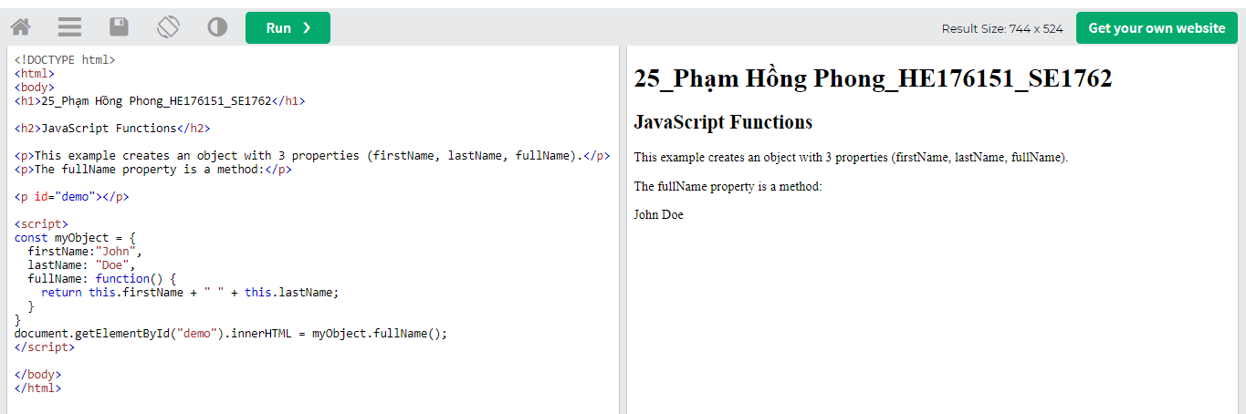

## The JavaScript call() Method

The call() method is a predefined JavaScript method.

It can be used to invoke (call) a method with an owner object as an argument (parameter).

With call(), an object can use a method belonging to another object.

This example calls the **fullName** method of person, using it on **person1**:

# Function Apply

## Method Reuse

With the apply() method, you can write a method that can be used on different objects.

## The Difference Between call() and apply()

The difference is:

The call() method takes arguments **separately**.

The apply() method takes arguments as an **array**.

The apply() method is very handy if you want to use an array instead of an argument list.

## Simulate a Max Method on Arrays

You can find the largest number (in a list of numbers) using the Math.max() method:

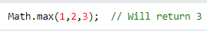

Since JavaScript **arrays** do not have a max() method, you can apply the Math.max() method instead.



# Function Bind

## Function Borrowing

With the bind() method, an object can borrow a method from another object.

The example below creates 2 objects (person and member).

The member object borrows the fullname method from the person object:

## Preserving this

Sometimes the bind() method has to be used to prevent losing **this**.

# Function Closures

JavaScript variables can belong to the **local** or **global** scope.

Global variables can be made local (private) with **closures**.

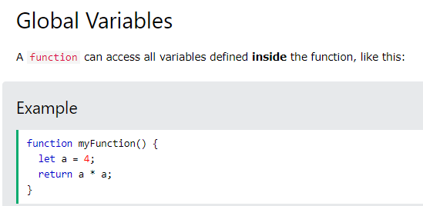

But a function can also access variables defined **outside** the function, like this:

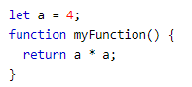

Variables created **without** a declaration keyword (var, let, or const) are always global, even if they are created inside a function.

## JavaScript Nested Functions

All functions have access to the global scope.

In fact, in JavaScript, all functions have access to the scope "above" them.

JavaScript supports nested functions. Nested functions have access to the scope "above" them.

# 

JS Async

# JS Callbacks

A callback is a function passed as an argument to another function

This technique allows a function to call another function

A callback function can run after another function has finished

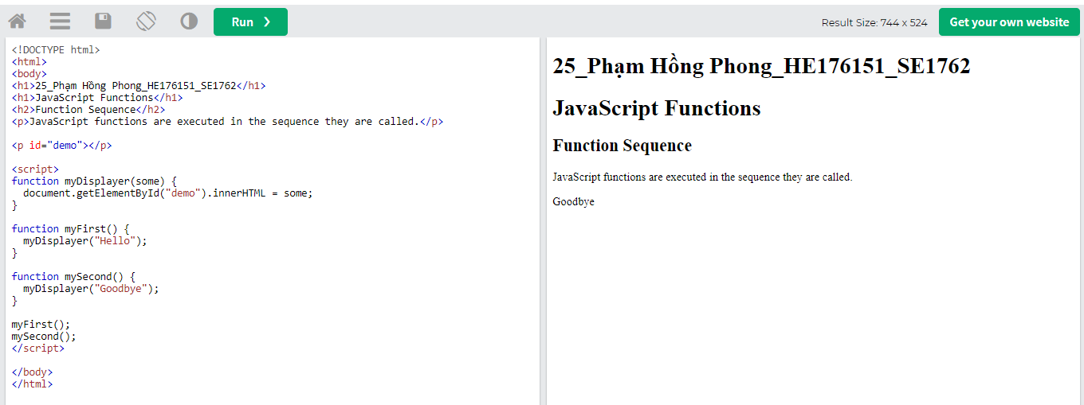

## Sequence Control

Sometimes you would like to have better control over when to execute a function.

Suppose you want to do a calculation, and then display the result.

You could call a calculator function (myCalculator), save the result, and then call another function (myDisplayer) to display the result:

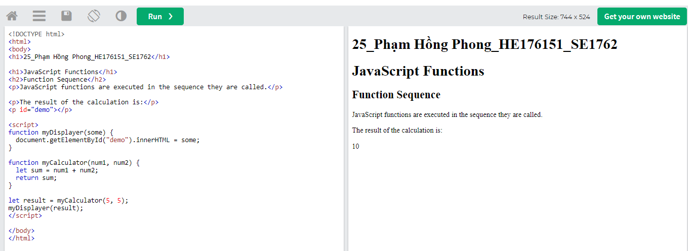

## JavaScript Callbacks

A callback is a function passed as an argument to another function.

Using a callback, you could call the calculator function (myCalculator) with a callback (myCallback), and let the calculator function run the callback after the calculation is finished:

## When to Use a Callback?

The examples above are not very exciting.

They are simplified to teach you the callback syntax.

Where callbacks really shine are in asynchronous functions, where one function has to wait for another function (like waiting for a file to load).

# JS Asynchronous

Functions running in **parallel** with other functions are called **asynchronous**

A good example is JavaScript setTimeout()

## Asynchronous JavaScript

The examples used in the previous chapter, was very simplified.

The purpose of the examples was to demonstrate the syntax of callback functions:

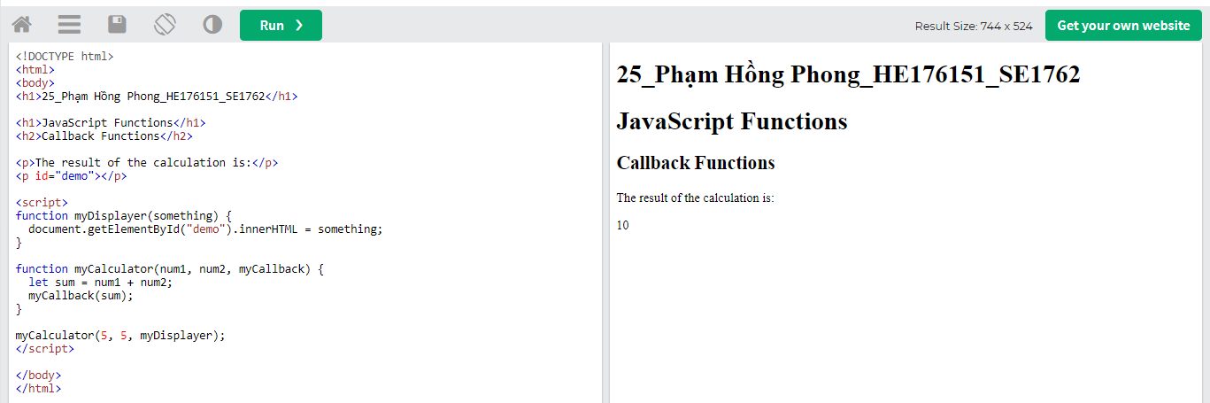

In the example above, myDisplayer is the name of a function.

It is passed to myCalculator() as an argument.

In the real world, callbacks are most often used with asynchronous functions.

A typical example is JavaScript setTimeout().

## Waiting for a Timeout

When using the JavaScript function setTimeout(), you can specify a callback function to be executed on time-out:

* setTimeout() để hàm thực hiện sau 1 khoảng thời gian ta set

## Callback Alternatives

With asynchronous programming, JavaScript programs can start long-running tasks, and continue running other tasks in paralell.

But, asynchronus programmes are difficult to write and difficult to debug.

Because of this, most modern asynchronous JavaScript methods don't use callbacks. Instead, in JavaScript, asynchronous programming is solved using **Promises** instead.

# JS Promises

## Promise Object Properties

A JavaScript Promise object can be:

* Pending
* Fulfilled
* Rejected

The Promise object supports two properties: **state** and **result**.

While a Promise object is "pending" (working), the result is undefined.

When a Promise object is "fulfilled", the result is a value.

When a Promise object is "rejected", the result is an error object.

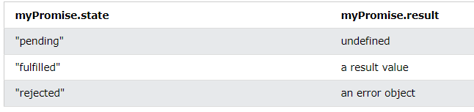

You cannot access the Promise properties **state** and **result**.

You must use a Promise method to handle promises.

# JS Async/Await

**async** makes a function return a Promise

**await** makes a function wait for a Promise

## Await Syntax

The await keyword can only be used inside an async function.

The await keyword makes the function pause the execution and wait for a resolved promise before it continues:

# 

JS HTML DOM

# DOM Intro

With the HTML DOM, JavaScript can access and change all the elements of an HTML document.

## The HTML DOM (Document Object Model)

When a web page is loaded, the browser creates a **D**ocument **O**bject **M**odel of the page.

The **HTML DOM** model is constructed as a tree of **Objects**:

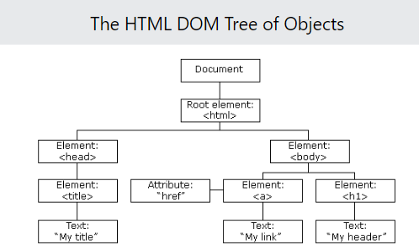

With the object model, JavaScript gets all the power it needs to create dynamic HTML:

* JavaScript can change all the HTML elements in the page
* JavaScript can change all the HTML attributes in the page
* JavaScript can change all the CSS styles in the page
* JavaScript can remove existing HTML elements and attributes
* JavaScript can add new HTML elements and attributes
* JavaScript can react to all existing HTML events in the page
* JavaScript can create new HTML events in the page

## What is the DOM?

The DOM is a W3C (World Wide Web Consortium) standard.

The DOM defines a standard for accessing documents:

*"The W3C Document Object Model (DOM) is a platform and language-neutral interface that allows programs and scripts to dynamically access and update the content, structure, and style of a document."*

The W3C DOM standard is separated into 3 different parts:

* Core DOM - standard model for all document types
* XML DOM - standard model for XML documents
* HTML DOM - standard model for HTML documents

## What is the HTML DOM?

The HTML DOM is a standard **object** model and **programming interface** for HTML. It defines:

* The HTML elements as **objects**
* The **properties** of all HTML elements
* The **methods** to access all HTML elements
* The **events** for all HTML elements

In other words: **The HTML DOM is a standard for how to get, change, add, or delete HTML elements.**

# DOM Methods

HTML DOM methods are **actions** you can perform (on HTML Elements).

HTML DOM properties are **values** (of HTML Elements) that you can set or change.

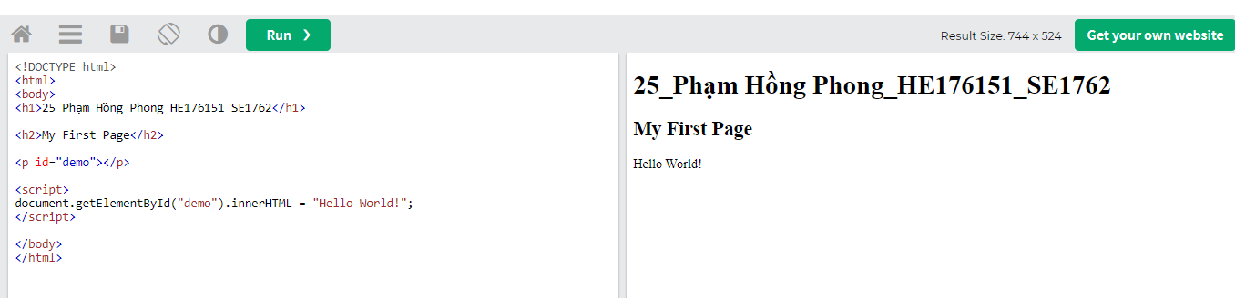

In the example above, getElementById is a **method**, while innerHTML is a **property**.

## The getElementById Method

The most common way to access an HTML element is to use the id of the element.

In the example above the getElementById method used id="demo" to find the element.

## The innerHTML Property

The easiest way to get the content of an element is by using the innerHTML property.

The innerHTML property is useful for getting or replacing the content of HTML elements.

# DOM Document

## The HTML DOM document object is the owner of all other objects in your web page.

## The HTML DOM Document Object

The document object represents your web page.

If you want to access any element in an HTML page, you always start with accessing the document object.

Below are some examples of how you can use the document object to access and manipulate HTML.

# 

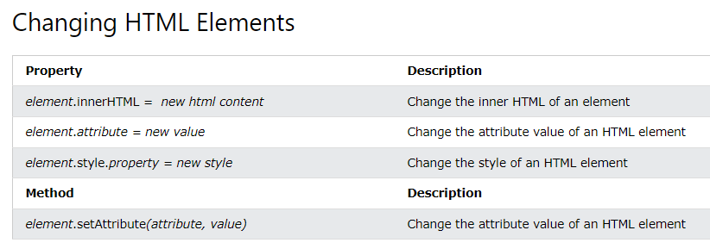

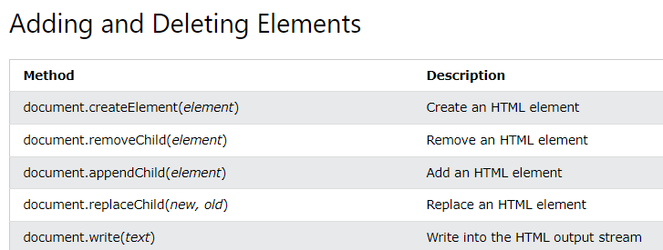

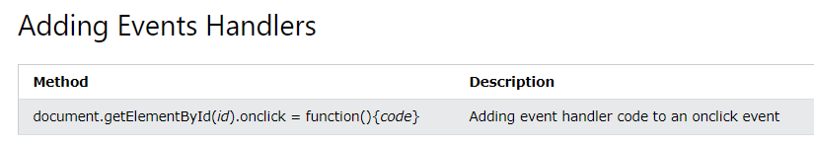

# DOM Elements

## Finding HTML Elements

Often, with JavaScript, you want to manipulate HTML elements.

To do so, you have to find the elements first. There are several ways to do this:

* Finding HTML elements by id
* Finding HTML elements by tag name
* Finding HTML elements by class name
* Finding HTML elements by CSS selectors
* Finding HTML elements by HTML object collections

## Finding HTML Element by Id

The easiest way to find an HTML element in the DOM, is by using the element id.

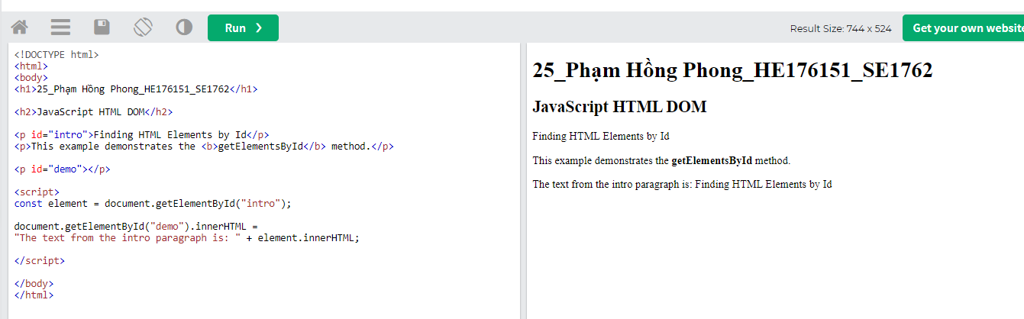

## Finding HTML Elements by Tag Name

## 

## Finding HTML Elements by Class Name



## Finding HTML Elements by CSS Selectors

If you want to find all HTML elements that match a specified CSS selector (id, class names, types, attributes, values of attributes, etc), use the querySelectorAll() method.

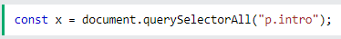

## Finding HTML Elements by HTML Object Collections

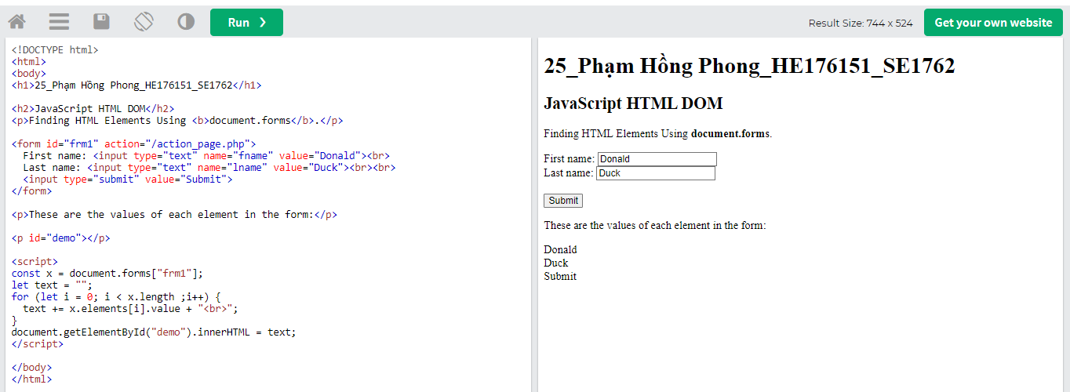

# DOM HTML

## Changing HTML Content



## Changing the Value of an Attribute



## document.write()

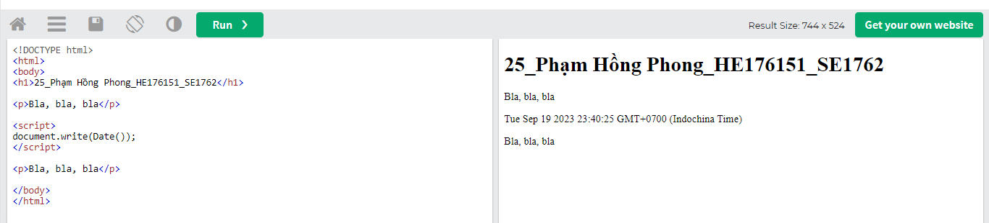

# DOM Forms

## JavaScript Form Validation

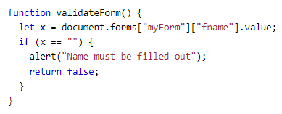

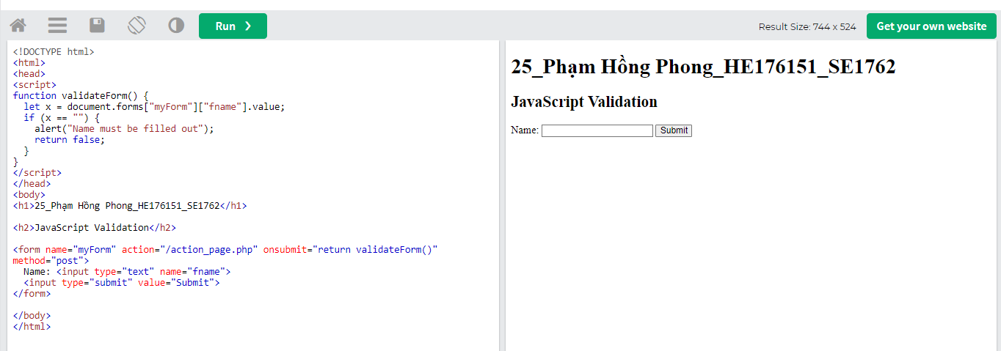

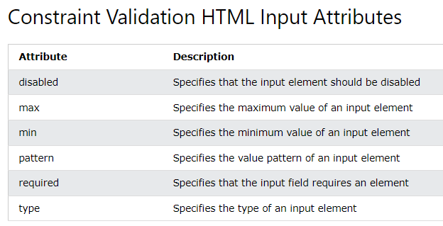

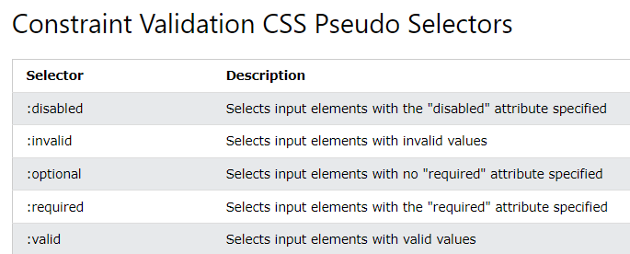

# DOM CSS

## Changing HTML Style



## Using Events

The HTML DOM allows you to execute code when an event occurs.

Events are generated by the browser when "things happen" to HTML elements:

* An element is clicked on
* The page has loaded
* Input fields are changed

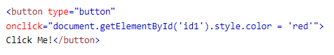

# DOM Animations

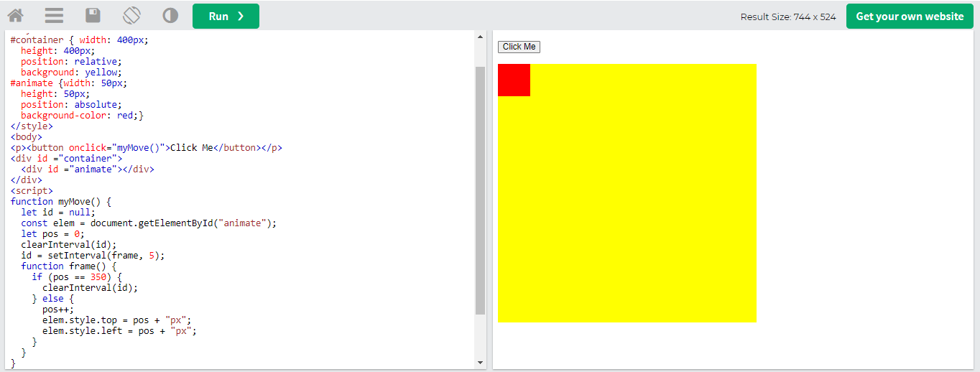

Click me -> box di chuyển xuống đáy bên phải của hình màu vàng

# DOM Events

## Reacting to Events

A JavaScript can be executed when an event occurs, like when a user clicks on an HTML element.

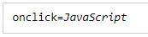

Examples of HTML events:

* When a user clicks the mouse
* When a web page has loaded
* When an image has been loaded
* When the mouse moves over an element
* When an input field is changed
* When an HTML form is submitted
* When a user strokes a key

## HTML Event Attributes

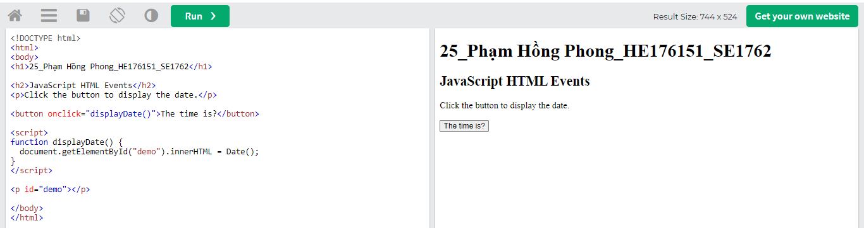

## The onload and onunload Events

The onload and onunload events are triggered when the user enters or leaves the page.

The onload event can be used to check the visitor's browser type and browser version, and load the proper version of the web page based on the information.

The onload and onunload events can be used to deal with cookies.

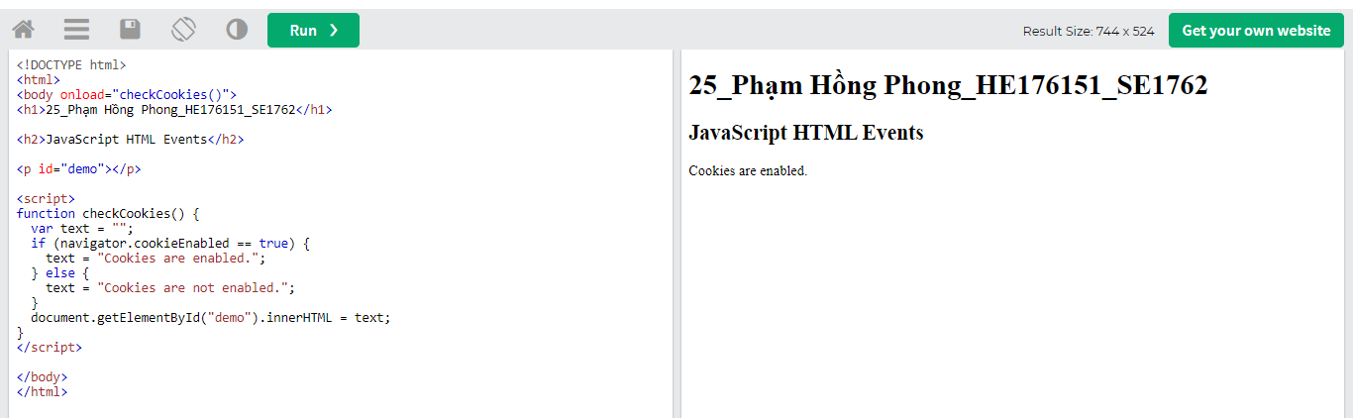

## The onchange Event

The onchange event is often used in combination with validation of input fields.

Below is an example of how to use the onchange. The upperCase() function will be called when a user changes the content of an input field.

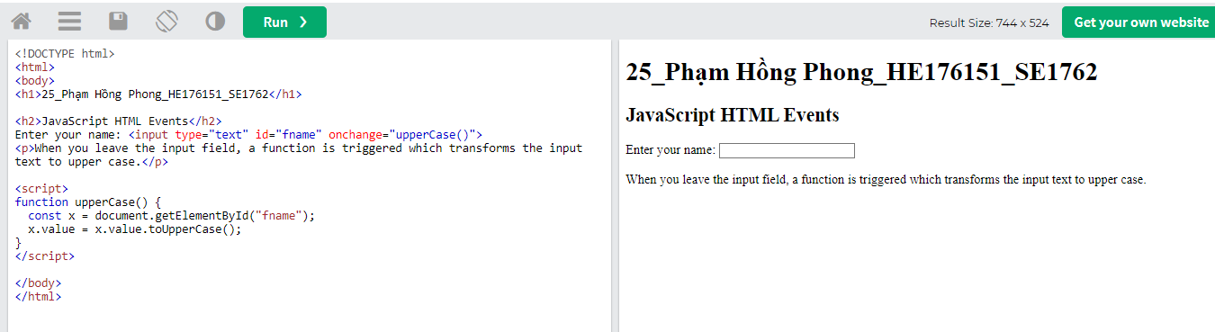

## The onmouseover and onmouseout Events

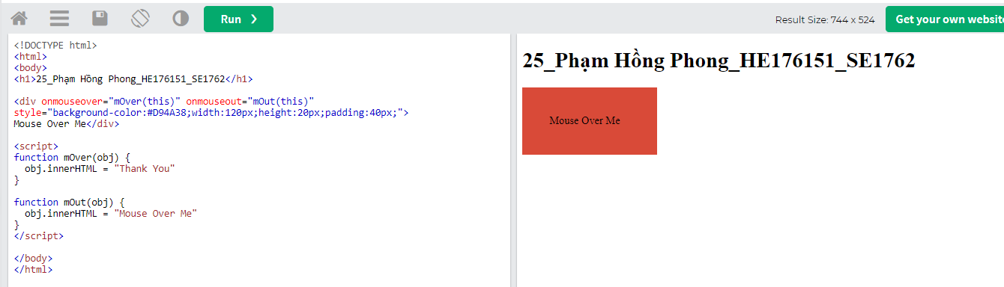

Đưa chuột vào box -> box đổi thành chữ “thank you”

## The onmousedown, onmouseup and onclick Events

The onmousedown, onmouseup, and onclick events are all parts of a mouse-click. First when a mouse-button is clicked, the onmousedown event is triggered, then, when the mouse-button is released, the onmouseup event is triggered, finally, when the mouse-click is completed, the onclick event is triggered

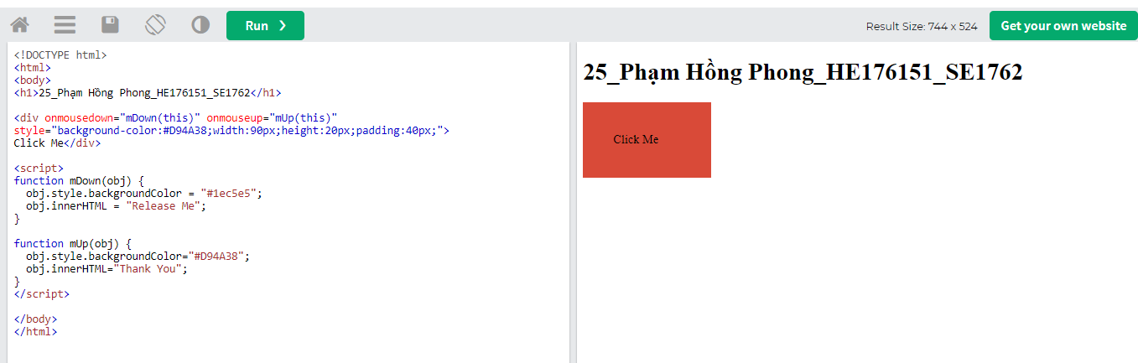

CLick giữ vào box -> box chuyển sang màu xanh và chuyển thành dòng chữ “Thank you”

[onmousedown and onmouseup](https://www.w3schools.com/js/tryit.asp?filename=tryjs_event_onmousedown)Change an image when a user holds down the mouse button.

[onload](https://www.w3schools.com/js/tryit.asp?filename=tryjs_event_onload)Display an alert box when the page has finished loading.

[onfocus](https://www.w3schools.com/js/tryit.asp?filename=tryjs_event_onfocus)Change the background-color of an input field when it gets focus.

[Mouse Events](https://www.w3schools.com/js/tryit.asp?filename=tryjs_event_onmouse)Change the color of an element when the cursor moves over it.

# DOM Event Listener

## The addEventListener() method



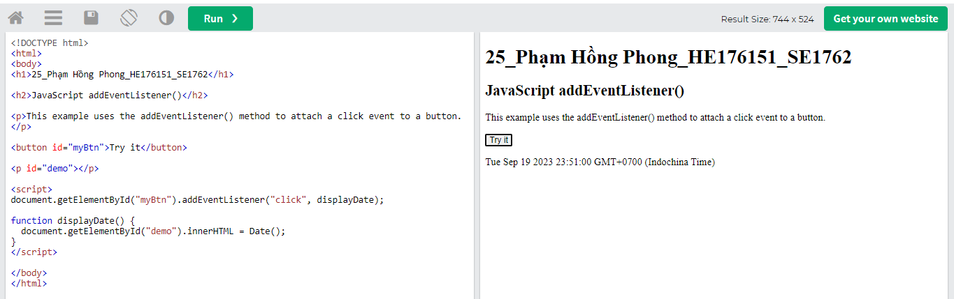

The addEventListener() method attaches an event handler to the specified element.

The addEventListener() method attaches an event handler to an element without overwriting existing event handlers.

You can add many event handlers to one element.

You can add many event handlers of the same type to one element, i.e two "click" events.

You can add event listeners to any DOM object not only HTML elements. i.e the window object.

The addEventListener() method makes it easier to control how the event reacts to bubbling.

When using the addEventListener() method, the JavaScript is separated from the HTML markup, for better readability and allows you to add event listeners even when you do not control the HTML markup.

You can easily remove an event listener by using the removeEventListener() method.

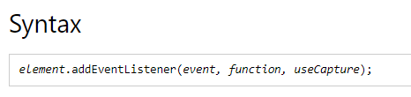

Note that you don't use the "on" prefix for the event; use "click" instead of "onclick".

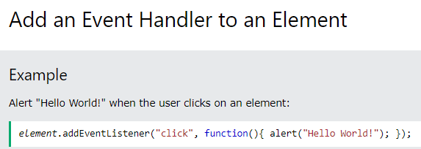

## The removeEventListener() method

The removeEventListener() method removes event handlers that have been attached with the addEventListener() method:

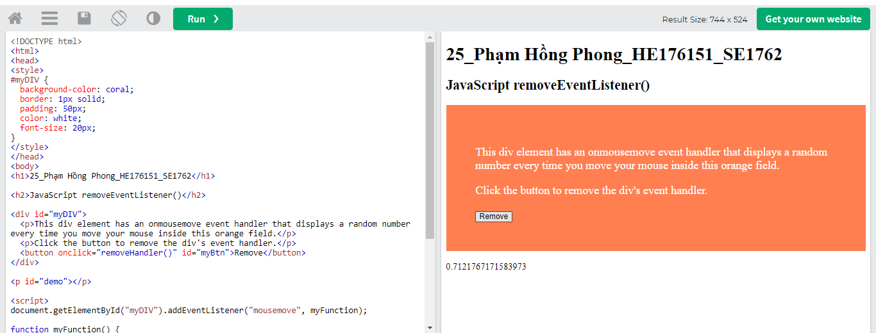

Click remove -> con số ở dưới dừng lại

# DOM Navigation

## DOM Nodes

According to the W3C HTML DOM standard, everything in an HTML document is a node:

* The entire document is a document node
* Every HTML element is an element node
* The text inside HTML elements are text nodes
* Every HTML attribute is an attribute node (deprecated)
* All comments are comment nodes

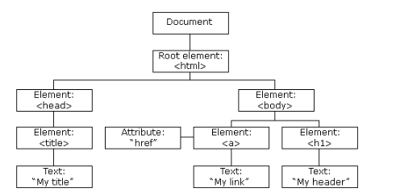

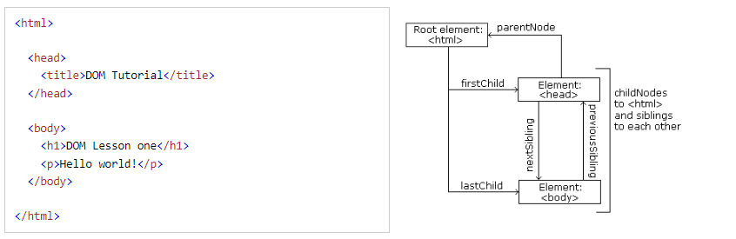

## Node Relationships

The nodes in the node tree have a hierarchical relationship to each other.

The terms parent, child, and sibling are used to describe the relationships.

* In a node tree, the top node is called the root (or root node)
* Every node has exactly one parent, except the root (which has no parent)
* A node can have a number of children
* Siblings (brothers or sisters) are nodes with the same parent

## Navigating Between Nodes

You can use the following node properties to navigate between nodes with JavaScript:

* parentNode
* childNodes[*nodenumber*]
* firstChild
* lastChild
* nextSibling
* previousSibling

## Child Nodes and Node Values

A common error in DOM processing is to expect an element node to contain text.

# DOM Nodes

AppendChild()

RemoveChild()

replaceChild()

# DOM Collections

## The HTMLCollection Object

The getElementsByTagName() method returns an HTMLCollection object.

An HTMLCollection object is an array-like list (collection) of HTML elements.

The following code selects all <p> elements in a document:

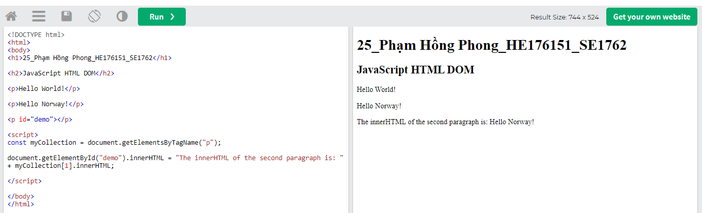

## HTML HTMLCollection Length

The length property defines the number of elements in an HTMLCollection:

**An HTMLCollection is NOT an array!**

An HTMLCollection may look like an array, but it is not.

You can loop through the list and refer to the elements with a number (just like an array).

However, you cannot use array methods like valueOf(), pop(), push(), or join() on an HTMLCollection

# DOM Node Lists

## The HTML DOM NodeList Object

A NodeList object is a list (collection) of nodes extracted from a document.

A NodeList object is almost the same as an HTMLCollection object.

Some (older) browsers return a NodeList object instead of an HTMLCollection for methods like getElementsByClassName().

All browsers return a NodeList object for the property childNodes.

Most browsers return a NodeList object for the method querySelectorAll().

The following code selects all <p> nodes in a document: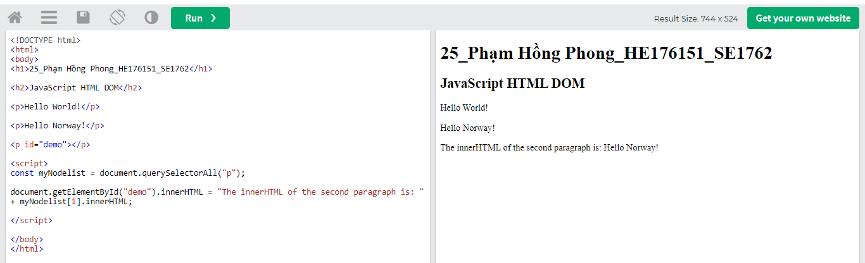

The Difference Between an HTMLCollection and a NodeList

A NodeList and an HTMLcollection is very much the same thing.

Both are array-like collections (lists) of nodes (elements) extracted from a document. The nodes can be accessed by index numbers. The index starts at 0.

Both have a length property that returns the number of elements in the list (collection).

An HTMLCollection is a collection of document elements.

A NodeList is a collection of document nodes (element nodes, attribute nodes, and text nodes).

HTMLCollection items can be accessed by their name, id, or index number.

NodeList items can only be accessed by their index number.

An HTMLCollection is always a live collection. Example: If you add a <li> element to a list in the DOM, the list in the HTMLCollection will also change.

A NodeList is most often a static collection. Example: If you add a <li> element to a list in the DOM, the list in NodeList will not change.

The getElementsByClassName() and getElementsByTagName() methods return a live HTMLCollection.

The querySelectorAll() method returns a static NodeList.

The childNodes property returns a live NodeList.

Not an Array!

A NodeList may look like an array, but it is not.

You can loop through a NodeList and refer to its nodes by index.

But, you cannot use Array methods like push(), pop(), or join() on a NodeList

Cheat sheets

<https://quickref.me/html?fbclid=IwAR19X99_m8ZIT17ZG1PvbDMTwTcDFPqP1j9nMXvaJA2oD1vvbrgtM_ngNzs>

<https://quickref.me/css3?fbclid=IwAR3TR1kp5nxNsIcGRBY7cO8bMiXbWKu2oMKHrx3ZyCS9Yhf6EyDHhnA-mhc>

<https://quickref.me/javascript?fbclid=IwAR1g-Lv-3J5DDZ6foTRBTse3sZrh_t2P0W2mQXpEL-ewkol_6cJP0lj8ruI>

Type system

js: vừa dynamic vừa weak

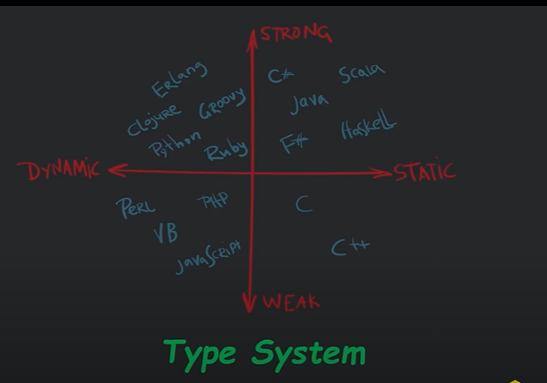

* static vs dynamic typing: quy định thời điểm xác định kiểu của biến

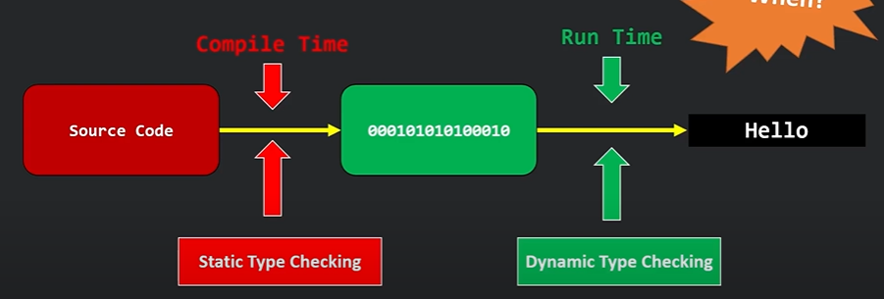

* strong vs weak typing: quy định cách thức convert kiểu của biến

weakly-typed languages make conversions between unrelated types implicity

VD: trong lúc runtime thì python sẽ không tự convert được từ số sang string (runtime error), ví dụ trong java thì nó sẽ báo lỗi compile. Còn js thì lúc chạy nó không báo lỗi mà tự convert số thành string luôn

Output

* document.write(): Using document.write() after an HTML document is loaded, will delete all existing HTML:
* window.print()
* 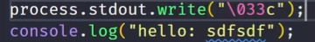

Statements

* JavaScript statements are composed of: Values, Operators, Expressions, Keywords, and Comments.
* line length: thường không quá 80 characters
* line break: the best place to break it is after an operator



Syntax

Values: 2 types

* Fixed values are called Literals: numbers or strings (để trong ‘ hoặc “)
* Variable values are called Variables.

Variables

When to Use JavaScript var?

Always declare JavaScript variables with var,let, or const.

The var keyword is used in all JavaScript code from 1995 to 2015.

The let and const keywords were added to JavaScript in 2015.

If you want your code to run in older browsers, you must use var.

A variable declared without a value will have the value undefined.

Re-Declaring JavaScript Variables: If you re-declare a JavaScript variable declared with **var**, it will not lose its value. You cannot re-declare a variable declared with **let** or **const**.

let x = "5" + 2 + 3; kết quả: 523

let x = 2 + 3 + "5"; kết quả: 55

1. Let

không thể redeclare;

Variables defined with let must be Declared before use.

Variables defined with let have Block Scope. (khi khai báo let trong block, biến đấy chỉ được dùng trong block, ngược lại var được dùng ngoài block)

1. so sánh redeclare giữa let và var

var: Redeclaring a JavaScript variable with var is allowed anywhere in a program

var x = 10;// Here x is 10

{

var x = 2;// Here x is 2

}

// Here x is 2

let: With let, redeclaring a variable in the same block is NOT allowed, Redeclaring a variable with let, in another block, IS allowed:

let x = 10;// Here x is 10

{

let x = 2;// Here x is 2

}

// Here x is 10

1. Let hoisting

var: You can use the variable before it is declared

let: Using a let variable before it is declared will result in a ReferenceError

1. const

* JavaScript const variables must be assigned a value when they are declared
* Use const when you declare:

A new Array

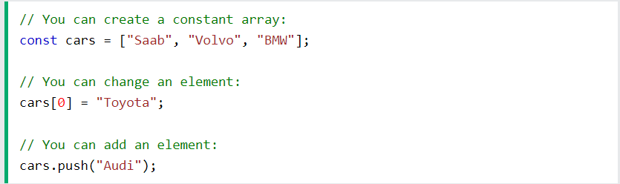

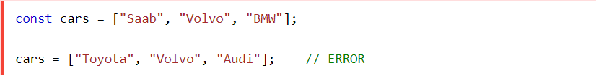

A new Object

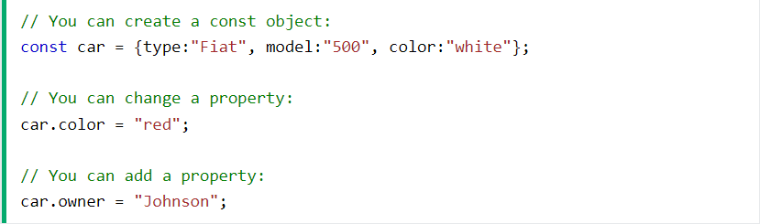

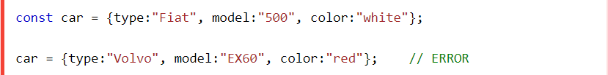

A new Function

A new RegExp

* Block scope: giống let

Data types

JavaScript has 8 Datatypes

1. String

2. Number

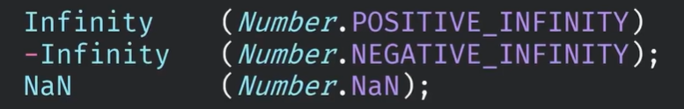

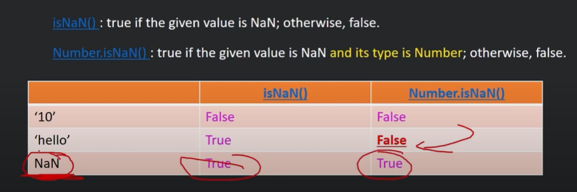

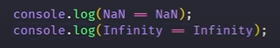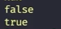

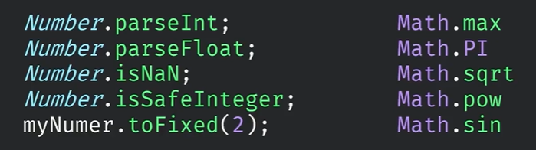

3. Bigint

* All JavaScript numbers are stored in a a 64-bit floating-point format.
* JavaScript BigInt is a new datatype (2020) that can be used to store integer values that are too big to be represented by a normal JavaScript Number.
* A BigInt can not have decimals.
* You cannot perform math between a BigInt type and a Number type.

4. Boolean

5. Undefined





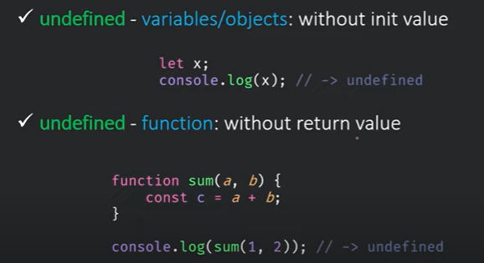

* function không truyền đủ param thì sẽ là undefined
* truy cập đến một property không tồn tại của object => undefined
* void 0 = undefined

6. Null

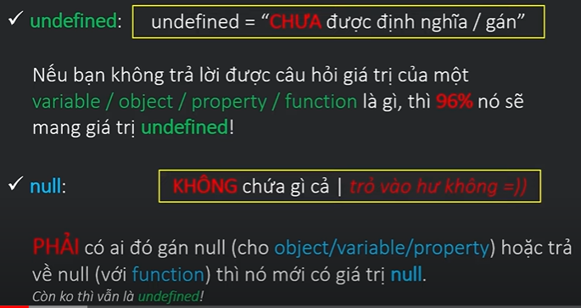

* là primitive value, nhưng dùng toán tử typeof thì trả về object
* ***Lưu ý:*** nếu cố gắng truy cập đến 1 property của 1 object null hoặc undefined => error. Ví dụ có object o1 = undefined, nma cố gắng truy cập đến 01.getAge() thì lỗi
* => phải check xem object (o1) có null hay undefined hay không để lúc chạy không lỗi

***Các cách check:***

* if (x): false khi x là undefined or null, empty string “”, 0, NaN, false
* if (x==undefined): true khi x là undefined or null. Nếu console.log(null==undefined) thì output là true. Nếu muốn tách biệt hẳn 2 type này ra thì dùng strict equal ===. Note: không được dùng undefined là key word/ tên biến
* if (x == void 0)
* if (x == null): tránh được lỗi dùng null là keyword của cách 2. Còn lại giống cách 2
* if (typeof x == “undefined”): only for undefined

7. Symbol

8. Object

The Object Datatype

The object data type can contain:

1. An object



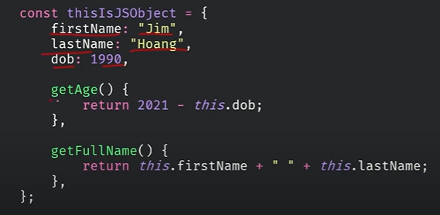object literal

* we can attach properties of methods to it

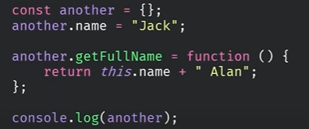

* you can create an object from a function (constructor function)

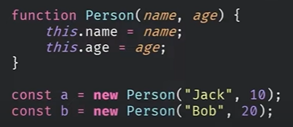

coding convention: viết hoa chữ cái đầu tiên (giống class)

vẫn có thể attach thêm property hoặc method cho a hoặc b

PROTOTYPE INHERITANCE

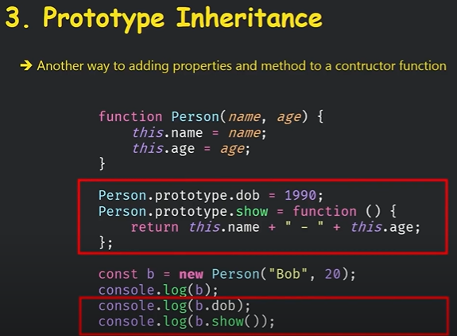

khi console.log ra object thì sẽ không hiện các thuộc tính prototype. Ngược lại, khi console.log ra  sẽ không hiện ra các thuộc tính bình thường của object

2. An array



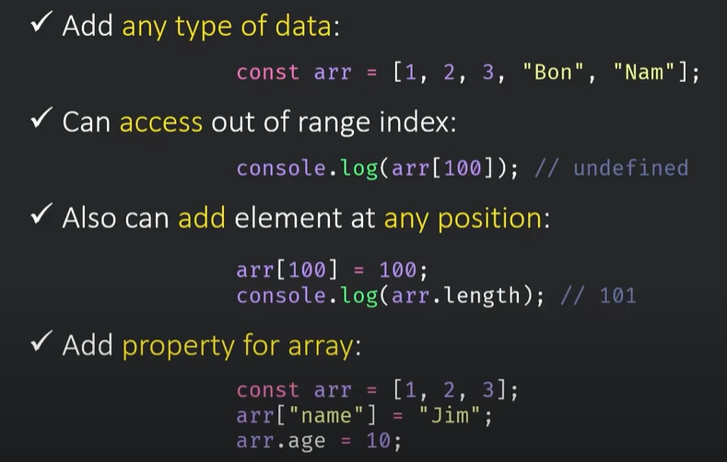

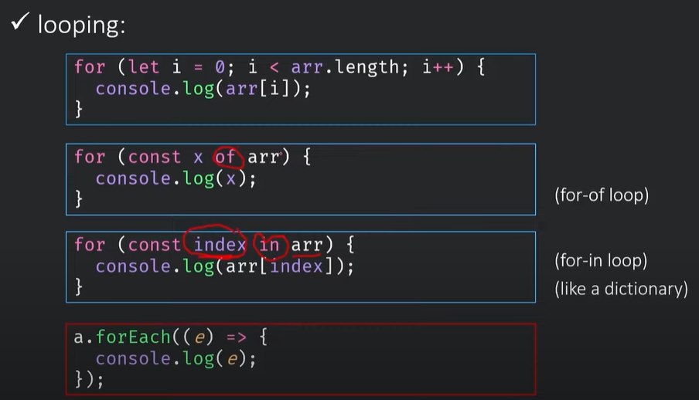

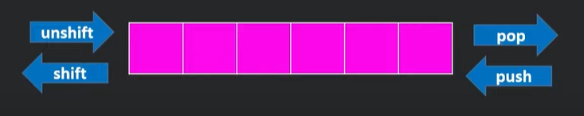

3. A date: <https://developer.mozilla.org/en-US/docs/Web/JavaScript/Reference/Global_Objects/Date?retiredLocale=vi>

type of

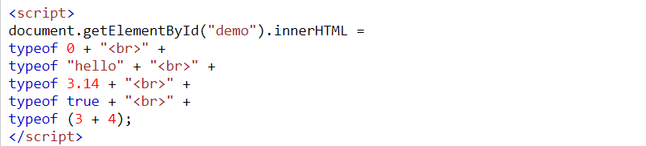

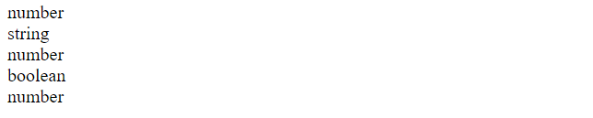

Functions

Accessing a function without () will return the function definition instead of the function result:

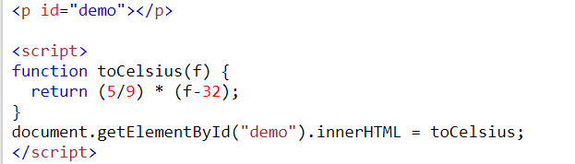



* function không có kiểu trả về và không có type, chỉ cần declare function tên (param)

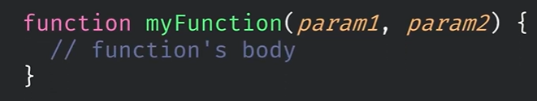

* a function can consider as a variable
* type: function

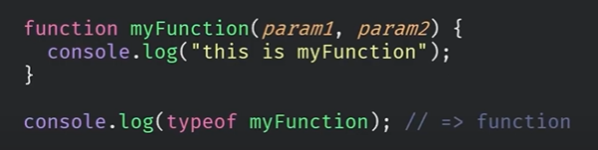

* can be re-assign to another value

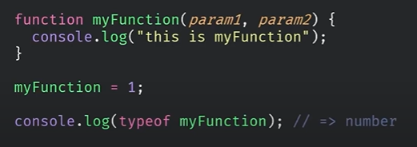

* can be used as parameter

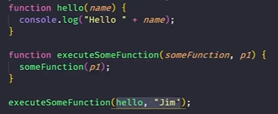

output: “Hello Jim”

* can be declare as a variable

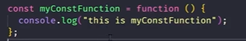

khai báo như khai báo 1 biến bth

lợi ích: không thể re-assign lại function vì nó được khai báo bằng const

* nested function

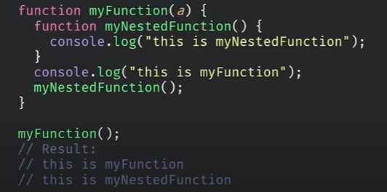

lợi ích: khi mình biết có những function chỉ làm việc trong myFuntion(), thì dùng đến nested function

bất lợi: nested function không dùng được ở ngoài block {}

* Parameter
* undefined: không truyền parameter vào function thì chỗ nào dùng đến param thì nó sẽ có giá trị là undefined
* default: mặc định nếu không truyền vào param thì param sẽ có giá trị default

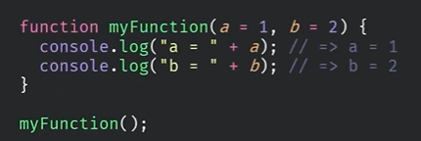

* rest-parameter: passing unknown number of parameters to function

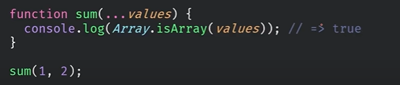

values type là array

* overloading function: trong js không tồn tại overloading function, vì nếu truyền khác số lượng tham số, thì tham số đấy sẽ là undefined

trong TH ảnh này, thì f bị ghi đè lên (re-assign)

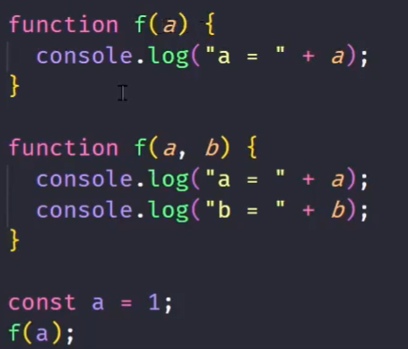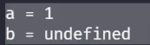

Arrow Function

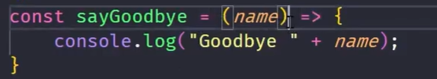

**Note**

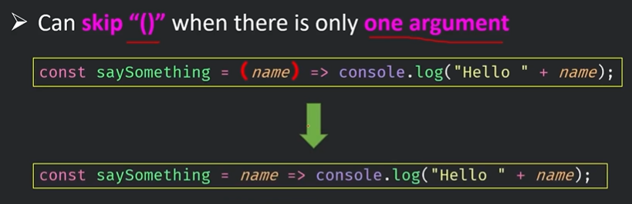

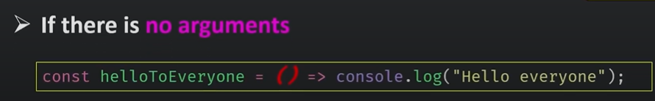

Nếu chỉ có 1 statement thì không cần {}

 trong TH này không cần return

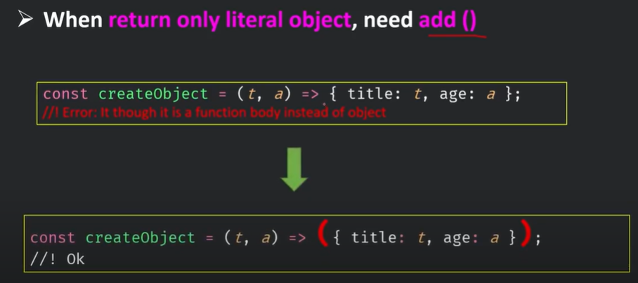

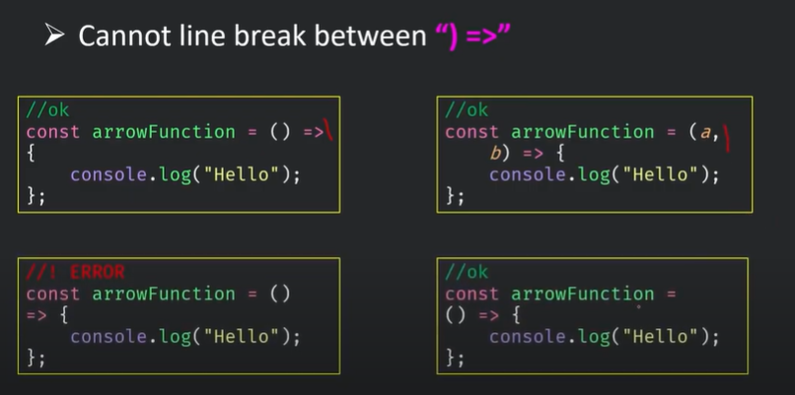

Objects

có property và method



It is a common practice to declare objects with the const keyword.

You can access object properties in two ways:

*objectName.propertyName*

or

*objectName["propertyName"]*

This

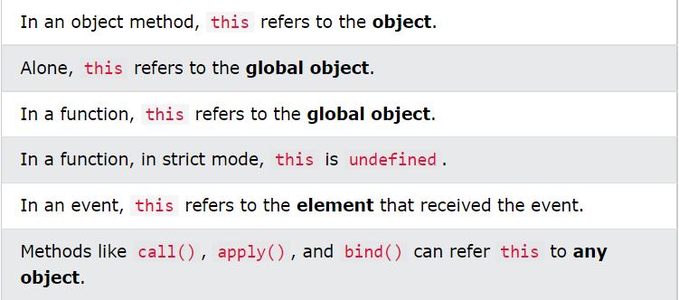

When a JavaScript variable is declared with the keyword "new", the variable is created as an object:

x = new String(); // Declares x as a String object

y = new Number(); // Declares y as a Number object

z = new Boolean(); // Declares z as a Boolean object

Avoid String, Number, and Boolean objects. They complicate your code and slow down execution speed.

Compare

nếu so sánh khác data type (trong đó có 1 number), trong hầu hết trường hợp nó sẽ convert sang kiểm number để so sánh

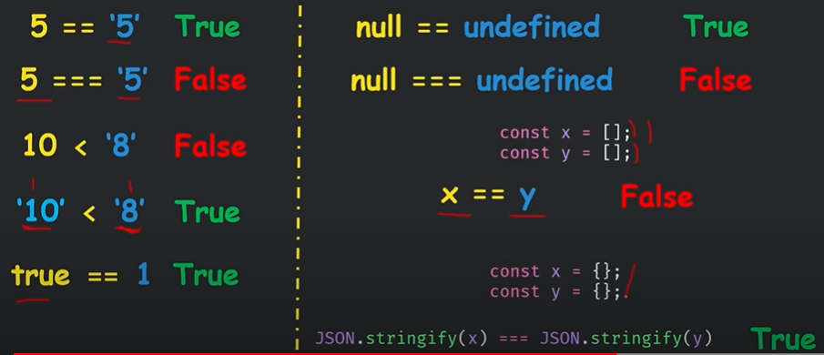

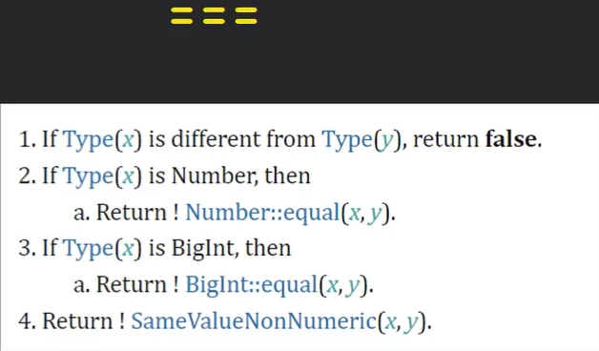

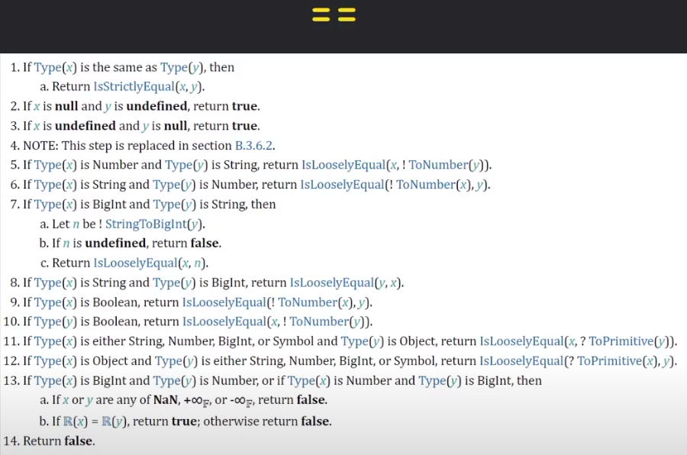

Operator

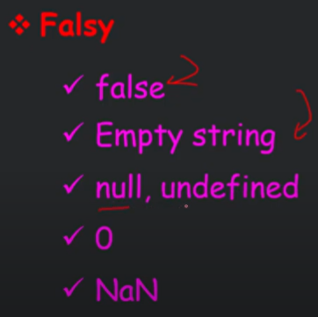

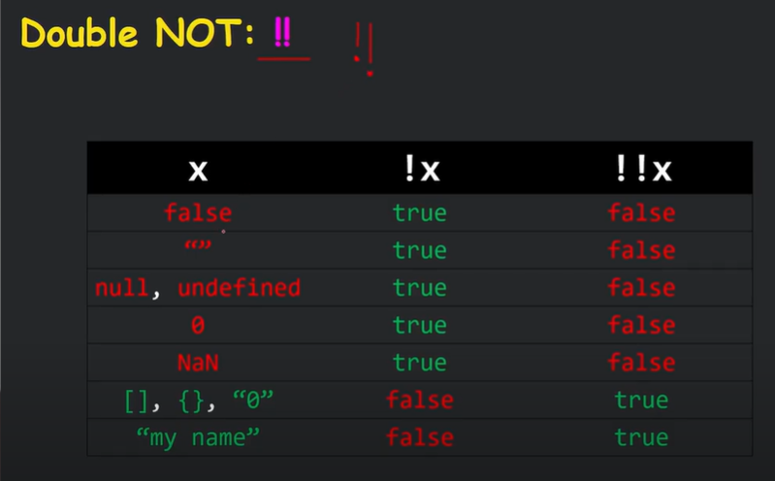dùng !! để so sánh === với true false

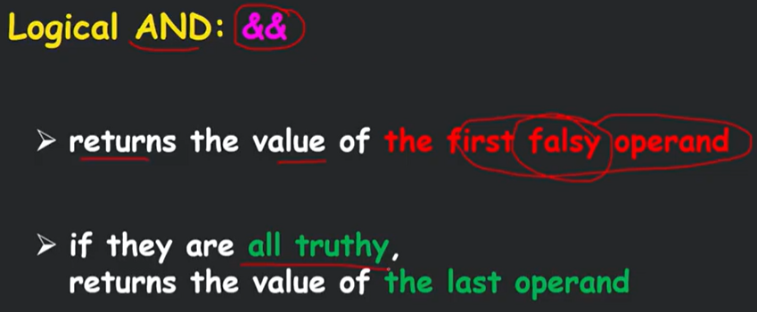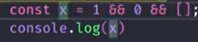

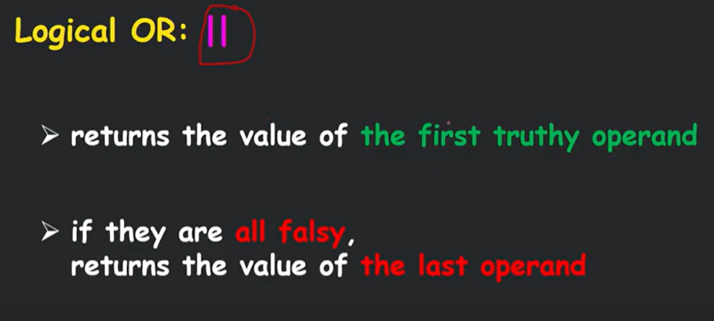

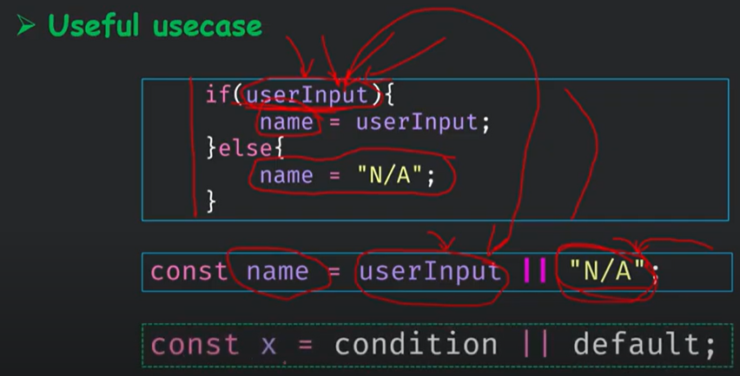

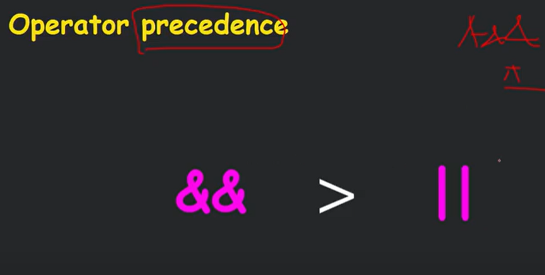

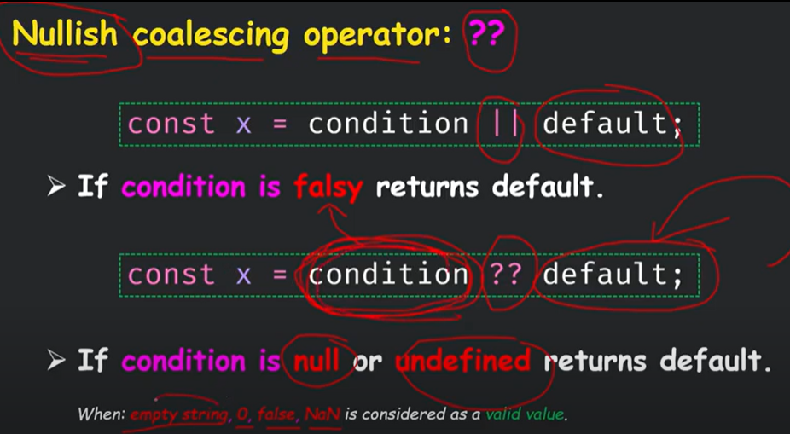

giống || nma strict hơn, chỉ null và undefined mới tính là false

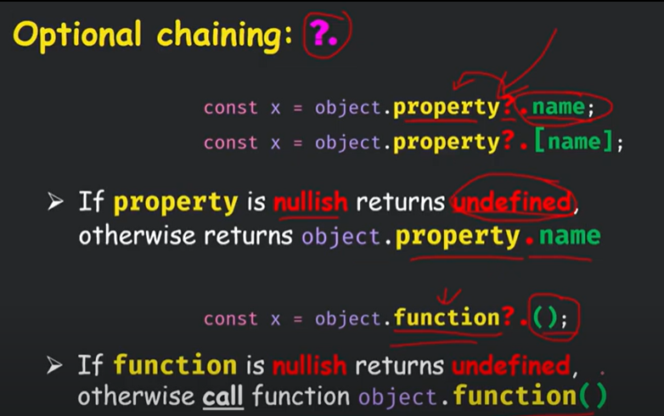

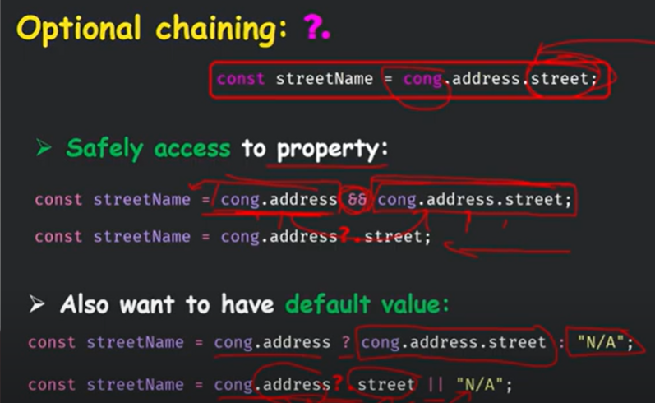

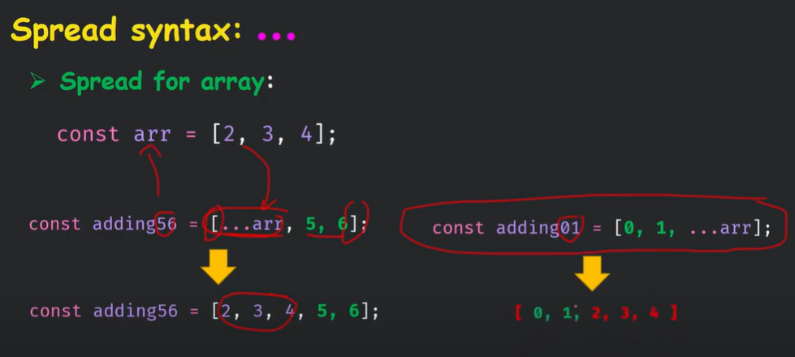

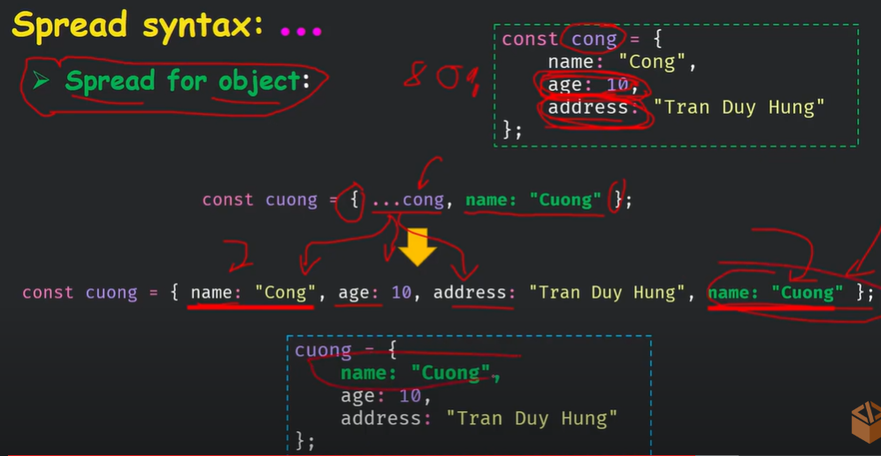

phần name: “Cuong” ở sau nên ghi đè lên name: “Cong”

Destructuring assignment

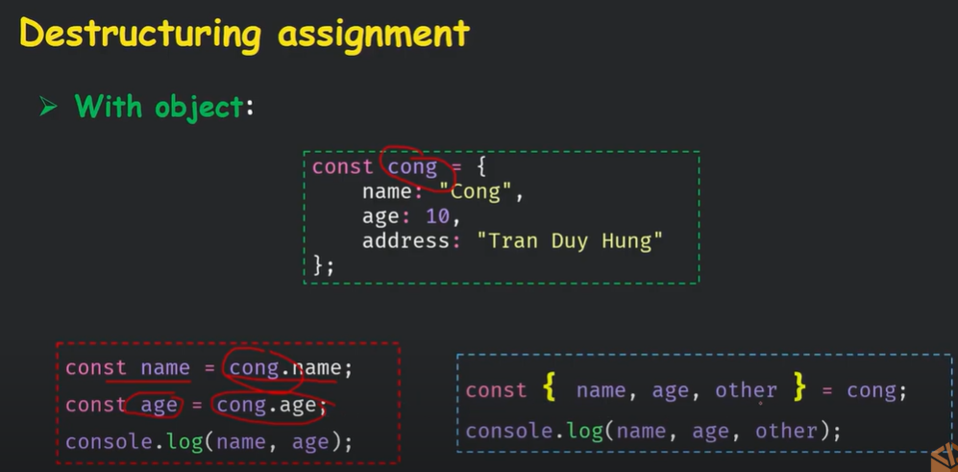

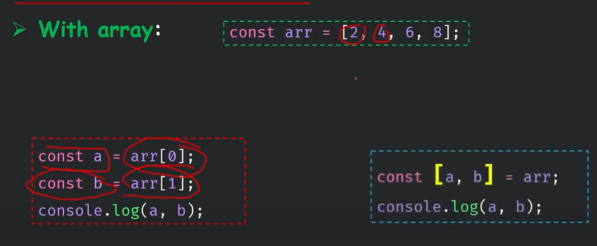

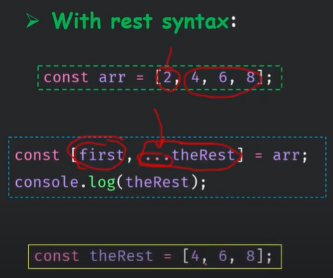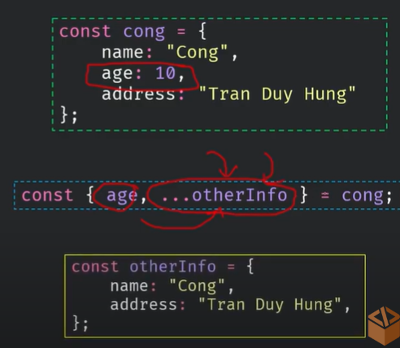

SET & MAP

* SET: không thể khởi tạo theo kiểu literal, phải dùng toán tử new để khởi tạo. Có thể truyền vào một array trong constructor

const mySet = new Set();

const mySet = new Set(arr);

* MAP: không thể khởi tạo theo kiểu literal, phải dùng toán tử new để khởi tạo

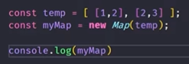 truyền vào mảng 2 chiều n*2

key là duy nhất, can be any type

value can be any type

Callbacks | Asynchronous programming

Callback functions: dùng 1 function như 1 argument của function khác

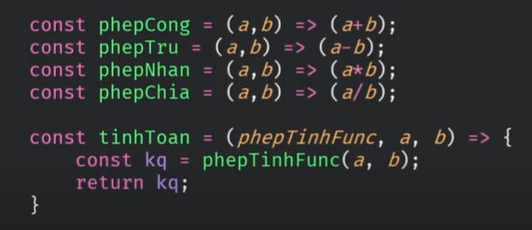

Tính năng quan trọng nhất là được sử dụng trong asynchronous, lập trình bất đồng bộ

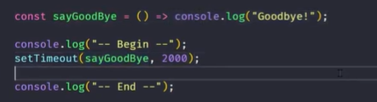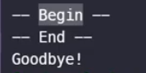

setTimeout: param1: function, param2: thời gian tính theo mili giây kể từ khi gọi đến khi thực hiện.

in ra Begin, sau đó process note lại là 2 giây sau sẽ in ra sayGoodBye, sau đó chạy tiếp (gọi End)



Trong TH function sayGoodBye có param của riêng nó, thì các param của nó sẽ được liệt kê lần là param thứ 3, 4, … của setTimeout

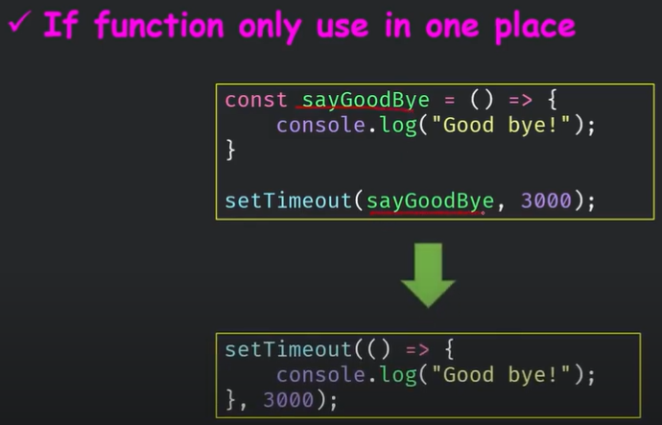

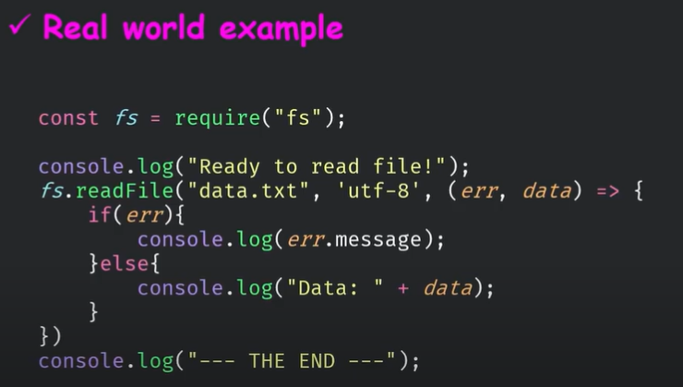

Callbacks | Utility Functions

* loop forEach

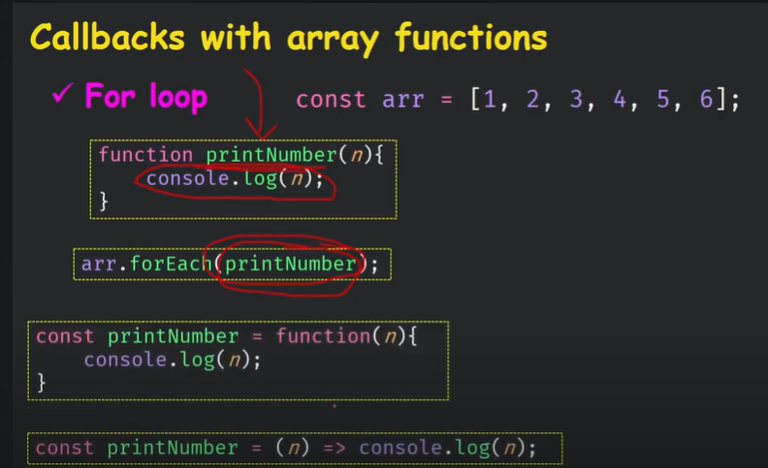

rút gọn hơn: 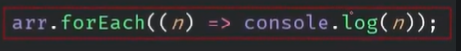

Nhưng n chỉ là lấy ra cái số hiện tại đang duyệt đến (bản copy) => thay đổi trên n không làm thay đổi phần tử mảng. Muốn thay đổi mảng (*2 các phần tử) thì dùng cách thứ hai:

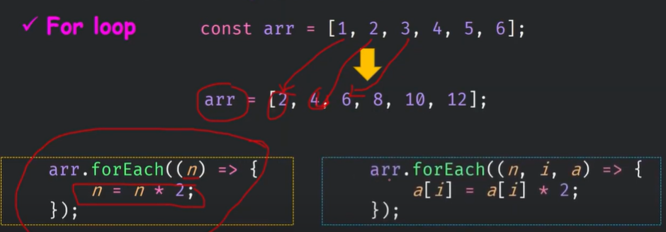

Trong đó, n là phần tử hiện tại, i là index của phần tử hiện tại, còn a là mảng đấy

* Map

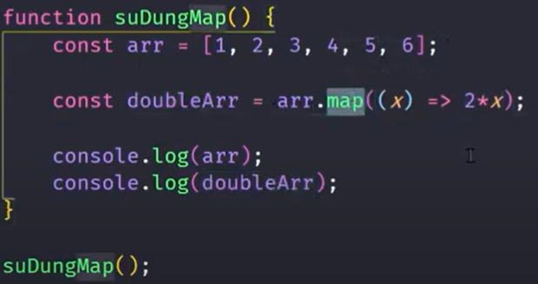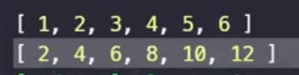

khác với forEach, map là ánh xạ 1-1, nghĩa là tạo 1 array mới chứ không thực hiện trực tiếp thay đổi trên array cũ

* filter

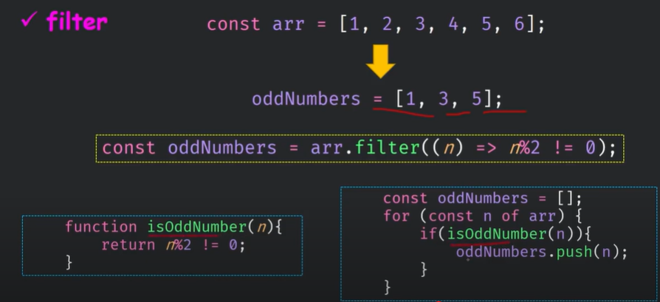

param là 1 call back function là predicate (function trả về true false)

* find

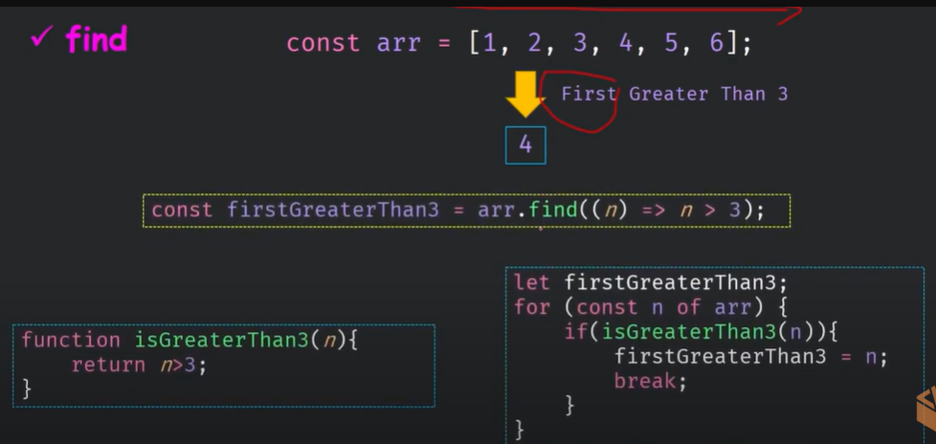

param truyền vào vẫn là predicate

Lưu ý: trả về phần tử đầu tiên thỏa mãn thôi, không liên quan các phần tử phía sau mà thỏa mãn

Ngoài ra còn có findIndex trả về index đầu tiên thỏa mãn

* sort

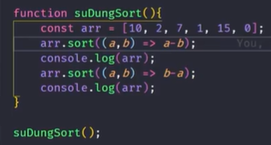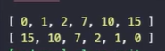

giống comparator

* reduce



* every | sum

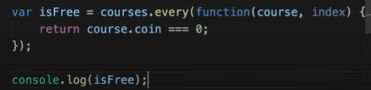//false

Một số hàm built-in

* alert
* console.log(), console.error(), console.warn()
* confirm(‘Xac nhan ban du tuoi’)

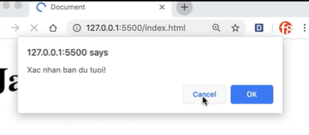

* prompt(‘Xac nhan ban du tuoi’)

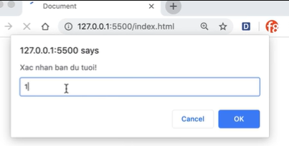

* setTimeout

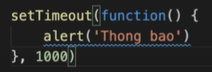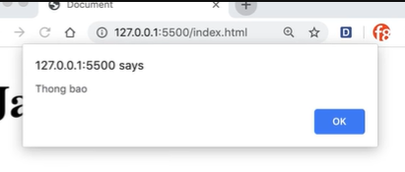

* setInterval

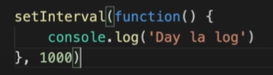

cách 1s là chạy 1 lần

Events

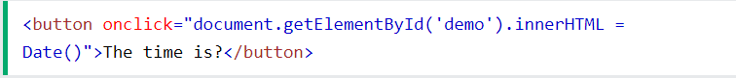

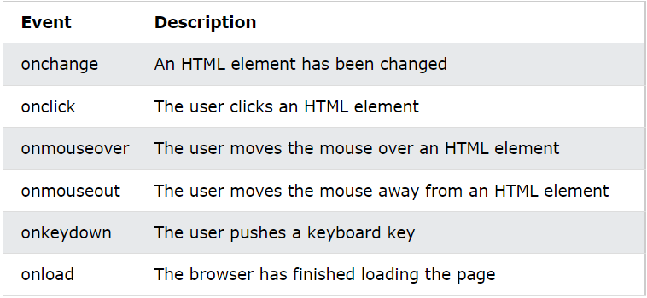

Strings

* string length: .length (vd: string.length)
* escape character: thêm dấu \ phía trước (vd: \” hoặc \’ hoặc \\)

\b Backspace

\f Form Feed

\n New Line

\r Carriage Return

\t Horizontal Tabulator

\v Vertical Tabulator

* breaking long code lines:

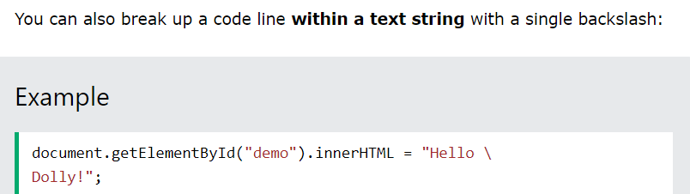

* strings can also be defined as objects with the keyword new:

let y = new String("John");

* Comparing two JavaScript objects always returns false.

String methods

<https://www.w3schools.com/js/js_string_methods.asp>

String length

String slice()

String substring()

String substr()

String replace()

String replaceAll()

String toUpperCase()

String toLowerCase()

String concat()

String trim()

String trimStart()

String trimEnd()

String padStart()

String padEnd()

String charAt()

String charCodeAt()

String split()

String Search

<https://www.w3schools.com/js/js_string_search.asp>

String indexOf()

String lastIndexOf()

String search()

String match()

String matchAll()

String includes()

String startsWith()

String endsWith()

Template Literals

<https://www.w3schools.com/js/js_string_templates.asp>

HTML DOM

stands for document object model

bao gồm 3 thành phần: element - attribute - text

Get element methods

* getElementByID(“ chuỗi “)
* getElementsByClassName(‘’)
* getElementsByTagName(‘’)
* querySelector(.header .header-name)
* querySelectorAll()

Set attribute

headingElement.title = “Heading”

trong TH set 1 attribute không hợp lệ thì dùng hàm set:

headingElement.setAttribute(“data-1”, “Heading”)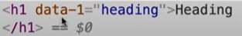

Get attribute value

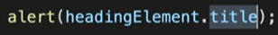

lấy value của attribute title



trong TH attribute không hợp lệ (data-1) thì dùng hàm get

* .attributes: list tất cả attr

text value

dùng Element.innerText hoặc Element.textContent để get text value

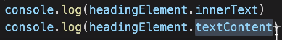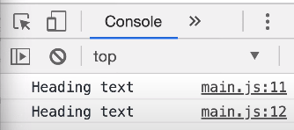





dùng innerText hoặc textContent đều có thể set laik value của text bằng toán tử gán

Điểm khác nhau: innerText như những gì mình nhìn thấy trên trình duyệt, còn textContent trả về text giống trong nguồn

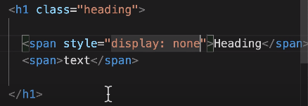

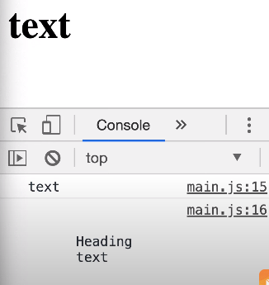

<https://www.youtube.com/watch?v=xwcQl75iSNc&list=PL_-VfJajZj0VgpFpEVFzS5Z-lkXtBe-x5&index=71>

add sub element

innerHTML, outerHTML

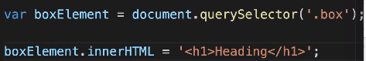

thêm element kèm theo attr của element đấy cũng oke

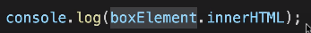

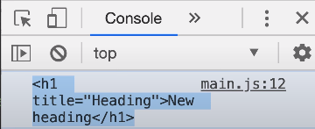

đồng thời nó cũng có thể là getter, lấy toán bộ nội dung của thằng class box

còn thằng outerHTML là chính thằng div box luôn

attr của element node

* style

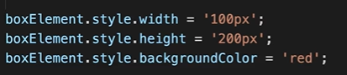

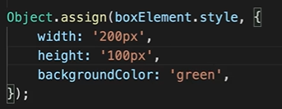 ngắn gọn hơn

* classList: trả về mảng các class
* add(‘red’, ‘blue’): thêm class red và blue vào element

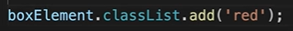

* contains(‘red’): trả về true false nếu element contain class red
* remove(‘red’): xóa class red ra khỏi element, nếu ngay từ đầu không có red thì cũng không lỗi
* toggle(‘red’): cái này hay nha, có class red rồi thì xóa, mà chưa có thì thêm vào

DOM events

các events: <https://www.w3schools.com/jsref/dom_obj_event.asp>

1. onchange, oninput

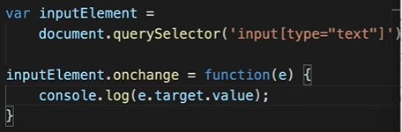

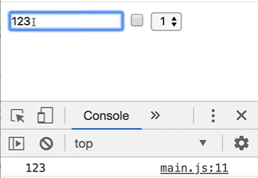

lấy ra value đã nhập vào ô input (khi value mới khác value cũ mới lấy)

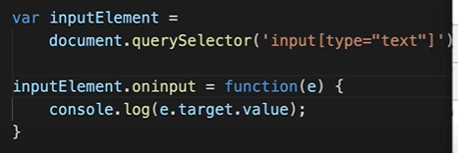

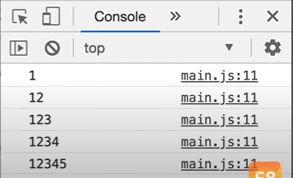

viết đến đâu lấy value ra đến đấy

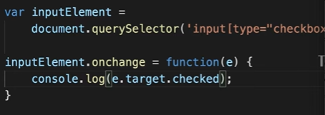

đối với checkbox thì muốn lấy ra giá trị của checkbox (true hoặc false) thì dùng .checked

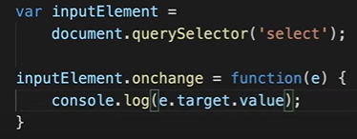

đối với dropbox, thì in ra value của cái nào user select

1. onkeyup, onkeydown

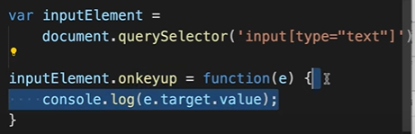

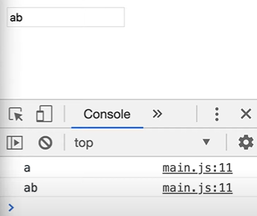

mỗi lần nhấc phím lên là thực hiện function, còn keydown là mỗi lần nhấn phím, onkeypress là nhấn rồi giữ thì thực hiện function

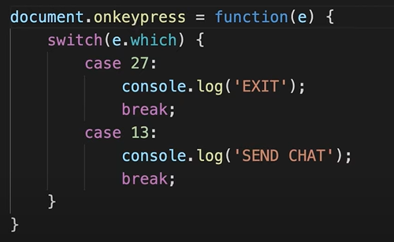

e.which là giá trị number của các nút (phím, ví dụ phím 1, 2, 3, enter, space)

cứ mỗi lần press nút esc (exit) thì console.log(exit), cứ mỗi lần press nút enter thì console.log(send chat)

1. onsubmit

JavaScript submit event occurs when user clicks on submit button to submit the form. Submit event is generally used to ask for confirmation from user to submit the form. The onsubmit event handler is used to handle this event.

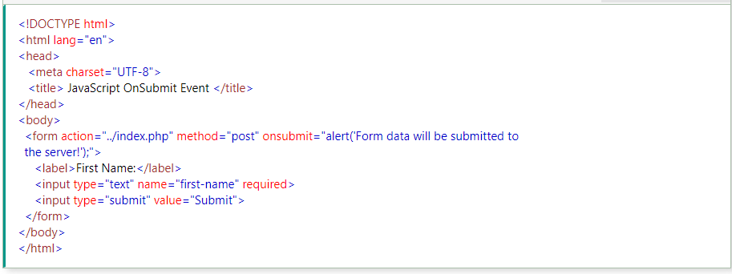

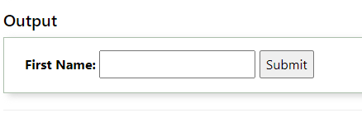

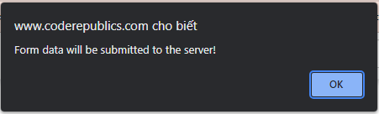

preventDefault and stopPropagation

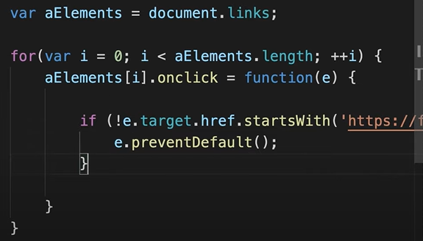

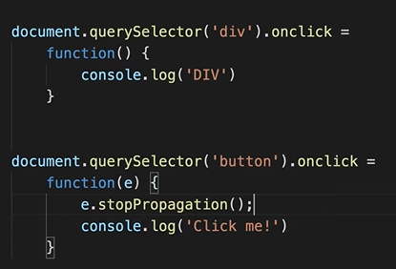

1. Some others

Examples

In HTML onclick is the event listener, myFunction is the event handler:

<button onclick="myFunction()">Click me</button>

In JavaScript click is the event, myFunction is the event handler:

button.addEventListener("click", myFunction);

Event Occurs When Belongs To

abort The loading of a media is aborted UiEvent, Event

afterprint A page has started printing Event

animationend A CSS animation has completed AnimationEvent

animationiteration A CSS animation is repeated AnimationEvent

animationstart A CSS animation has started AnimationEvent

beforeprint A page is about to be printed Event

beforeunload Before a document is about to be unloaded UiEvent, Event

blur An element loses focus FocusEvent

canplay The browser can start playing a media (has buffered enough to begin) Event

canplaythrough The browser can play through a media without stopping for buffering Event

change The content of a form element has changed Event

click An element is clicked on MouseEvent

contextmenu An element is right-clicked to open a context menu MouseEvent

copy The content of an element is copied ClipboardEvent

cut The content of an element is cut ClipboardEvent

dblclick An element is double-clicked MouseEvent

drag An element is being dragged DragEvent

dragend Dragging of an element has ended DragEvent

dragenter A dragged element enters the drop target DragEvent

dragleave A dragged element leaves the drop target DragEvent

dragover A dragged element is over the drop target DragEvent

dragstart Dragging of an element has started DragEvent

drop A dragged element is dropped on the target DragEvent

durationchange The duration of a media is changed Event

ended A media has reach the end ("thanks for listening") Event

error An error has occurred while loading a file ProgressEvent, UiEvent, Event

focus An element gets focus FocusEvent

focusin An element is about to get focus FocusEvent

focusout An element is about to lose focus FocusEvent

fullscreenchange An element is displayed in fullscreen mode Event

fullscreenerror An element can not be displayed in fullscreen mode Event

hashchange There has been changes to the anchor part of a URL HashChangeEvent

input An element gets user input InputEvent, Event

invalid An element is invalid Event

keydown A key is down KeyboardEvent

keypress A key is pressed KeyboardEvent

keyup A key is released KeyboardEvent

load An object has loaded UiEvent, Event

loadeddata Media data is loaded Event

loadedmetadata Meta data (like dimensions and duration) are loaded Event

loadstart The browser starts looking for the specified media ProgressEvent

message A message is received through the event source Event

mousedown The mouse button is pressed over an element MouseEvent

mouseenter The pointer is moved onto an element MouseEvent

mouseleave The pointer is moved out of an element MouseEvent

mousemove The pointer is moved over an element MouseEvent

mouseover The pointer is moved onto an element MouseEvent

mouseout The pointer is moved out of an element MouseEvent

mouseup A user releases a mouse button over an element MouseEvent

mousewheel Deprecated. Use the wheel event instead WheelEvent

offline The browser starts working offline Event

online The browser starts working online Event

open A connection with the event source is opened Event

pagehide User navigates away from a webpage PageTransitionEvent

pageshow User navigates to a webpage PageTransitionEvent

paste Some content is pasted in an element ClipboardEvent

pause A media is paused Event

play The media has started or is no longer paused Event

playing The media is playing after beeing paused or buffered Event

popstate The window's history changes PopStateEvent

progress The browser is downloading media data Event

ratechange The playing speed of a media is changed Event

resize The document view is resized UiEvent, Event

reset A form is reset Event

scroll An scrollbar is being scrolled UiEvent, Event

search Something is written in a search field Event

seeked Skipping to a media position is finished Event

seeking Skipping to a media position is started Event

select User selects some text UiEvent, Event

show A <menu> element is shown as a context menu Event

stalled The browser is trying to get unavailable media data Event

storage A Web Storage area is updated StorageEvent

submit A form is submitted Event

suspend The browser is intentionally not getting media data Event

timeupdate The playing position has changed (the user moves to a different point in the media) Event

toggle The user opens or closes the <details> element Event

touchcancel The touch is interrupted TouchEvent

touchend A finger is removed from a touch screen TouchEvent

touchmove A finger is dragged across the screen TouchEvent

touchstart A finger is placed on a touch screen TouchEvent

transitionend A CSS transition has completed TransitionEvent

unload A page has unloaded UiEvent, Event

volumechange The volume of a media is changed (includes muting) Event

waiting A media is paused but is expected to resume (e.g. buffering) Event

wheel The mouse wheel rolls up or down over an element WheelEvent

event listener

1. event listener

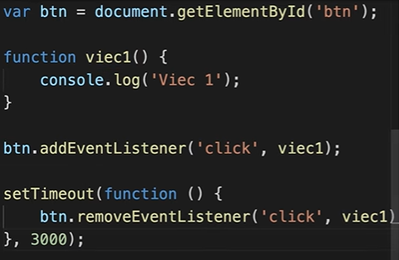

có thể add cũng có thể remove function

sau 3 giây thì click cũng không thể thực hiện function viec1 được nữa

=> dùng DOM event khi muốn lắng nghe việc nào đó nhưng mà không có nhu cầu gỡ đi (muốn dùng cũng được nma phải ghi đè function), khi muốn gỡ event thì dùng event listener

1. JSON
2. fetch
3. DOM location
4. Local storage
5. Session storage
6. Coding convention
7. Best practices
8. Mistakes
9. Performance

Table

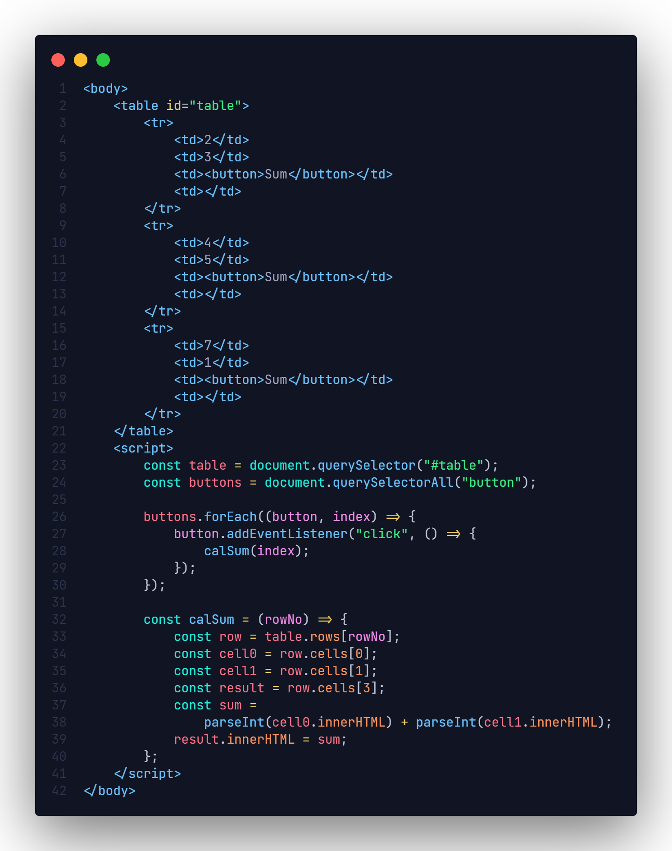

Form

* reset()

reset lại data của 1 form. form sẽ có method reset()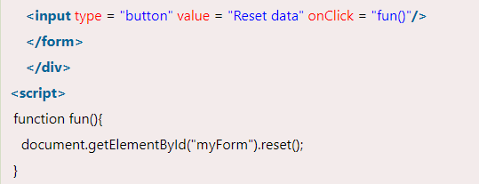

* .elements

trả về các elements (mảng) trong form

* attribute name

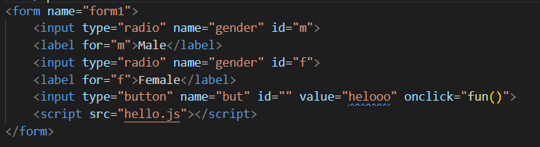

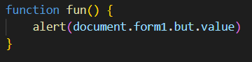

có thể get form bằng cách document.form1, rồi tất cả các element của form có thể get bằng name

* namedItem(id):

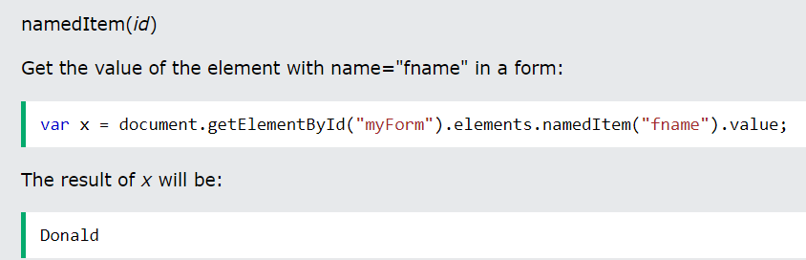

* attribute action

The action attribute defines the action to be performed when the form is submitted.

* Target Attribute

The target attribute specifies where to display the response that is received after submitting the form.

The target attribute can have one of the following values:

Value Description

_blank The response is displayed in a new window or tab

_self The response is displayed in the current window

_parent The response is displayed in the parent frame

_top The response is displayed in the full body of the window

framename The response is displayed in a named iframe

The default value is _self which means that the response will open in the current window.

* The <fieldset> and <legend> Elements

The <fieldset> element is used to group related data in a form.

The <legend> element defines a caption for the <fieldset> element.



 

 